To all Great Milton Parish Councillors:

You are summonsed to attend the ANNUAL GREAT MILTON PARISH COUNCIL MEETING on Monday 21st May 2012 at 7.30pm in the Pavilion:

AGENDA
48/12 Apologies for Absence

49/12 To Elect a Chairman

50/12 To Elect a Vice-Chairman

51/12 To nominate representatives for:
The Sheppard Trust
The Hard Surface Play Area Committee
Great Milton Recreation Ground Management Committee
Neighbourhood Watch
The Kent & Couling Charity
The Old Field Charity

52/12 Inventory of Parish Documents
To confirm the inventory of documents held by the Clerk and County Records Office.

53/12 Revision of Standing Orders
To consider the Parish Council’s Standing Orders and make revisions as necessary.

54/12 Revision and Confirmation of Insurance Arrangements
To consider the Parish Council’s insurance arrangements and make revisions as necessary.

55/12 Register of Interests for this Meeting
To receive declarations of interest in matters on the Agenda.

56/12 Minutes of the Previous Meeting
To approve and sign the minutes of the meeting held on Monday 16th April 2012 and the Planning Meeting held on Tuesday 8th May 2012.

57/12 Matters to Report
To receive an update on matters progressed since the last meeting not appearing as Agenda items and reports from District and County Cllrs if present.

58/12 Correspondence and Public Discussion
To receive items of correspondence and take questions from the public.

59/12 Planning Applications
A There are no new Planning Applications to consider at this meeting.
B To review any planning decisions received and any outstanding planning matters.

60/12 Dog Bins
To consider an offer from Le Manoir aux Quat’Saisons to sponsor the purchase of two dog bins for the Parish and to approve the expenditure at £81 plus VAT per bin. Also, to approve the emptying costs (to be borne by the Parish Council), of approximately £40 per year per bin.

61/12 Pegswell Lane
To review the quotations and estimates for the work required to restore and make safe the area surrounding the well at the end of the definitive public footpath, Pegswell Lane, and to agree any expenditure or earmarking of funds.

62/12 Extension of Leases to Great Milton School
To receive an update on the recent site meeting at the school and review the options for extending the leases to the school of former allotment land for the Hard Surface Play Area and Early Years Play Area.

63/12 Damage to Verges
To discuss reports from residents of reparations required to verges near Brannock and Stonefield in Lower End and to agree on appropriate action and expenditure.

64/12 Financial Resolutions
A To authorise cheques for payment:

Joanna Botha. Salary. £367.20
Jonathan Dudley. Bulletin editorial and production. £409.20
Gillett & Johnson. Clock Servicing. £202.80 (Original cheque did not arrive so has been stopped).
Broker Network Ltd. PC Insurance. £337.79
ORCC. Unspent grant money for Parish Plan. £151.25

B To review and approve the Internal Audit Plan.

65/11 Any Other Business

All members of the press and public are very welcome at this meeting.

The next meeting of the Great Milton Parish Council will be held on Monday June 18th 2012 starting at 7.30pm in The Pavilion.

Signed:
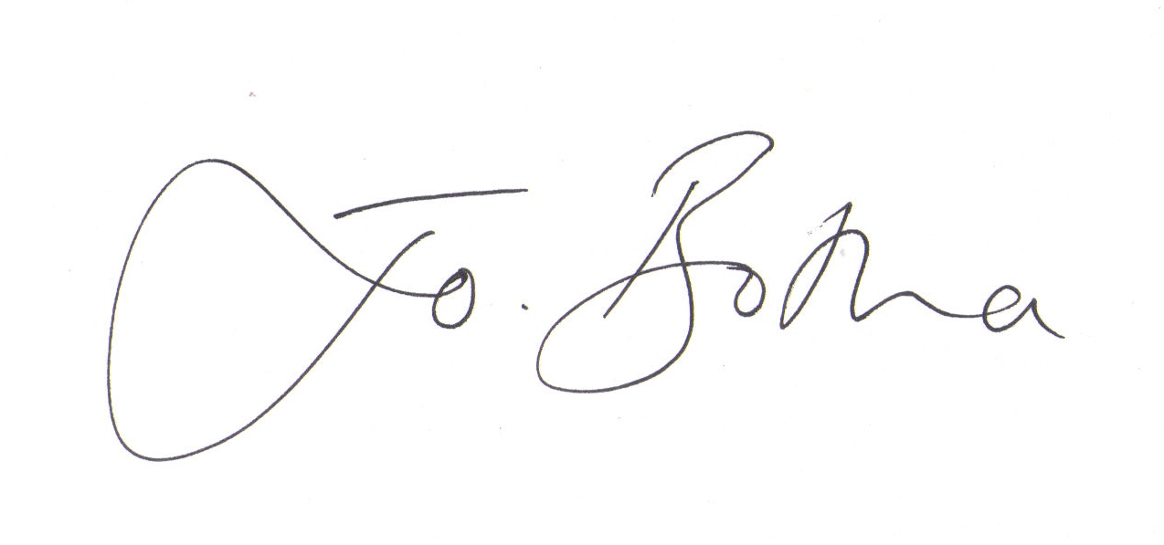

Joanna Botha
Clerk/Responsible Finance Officer to Great Milton Parish Council

