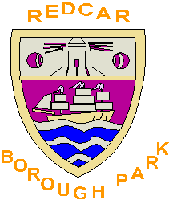
Outdoor Bowling 2021
Redcar Borough Park Bowling Club
Bowling Charges

Purchase your ticket before you start bowling!
If you are nominating to play in any of the leagues, you must hold a season ticket. We would also encourage all social bowlers to purchase a ticket as it is generally more economical over the season.
Season Ticket Purchase Prices -
Start Playing Before 31st May costs £35.
Start Playing From 1st June costs £25.
Start Playing After 31st July costs £10.

The £1 charge for league games remains the same. This is to cover travelling etc.

Roll-ups for anyone bowling on the outdoor greens, who are not season ticket holders, will cost £2.50 per game (£3.00 for non-members).

Club competition entry fee is £2 per bowler and will be collected by the Competition Secretary.

Other monies to be placed in the post-box outside the main entrance if the club is closed, or in the hallway post-box.
Bank Transfers to - Redcar Borough Park Bowling Club Gen A/C
Sort Code 05-07-02 Account 14231272 Ref. Season Ticket

