THE WORK PARTY
On Monday 3rd Aug a motley crew appeared at Hampden Park rehabilitation centre. Their crime was to volunteer to paint the clubhouse. Locked inside and behind bars they were all safe away from the public.
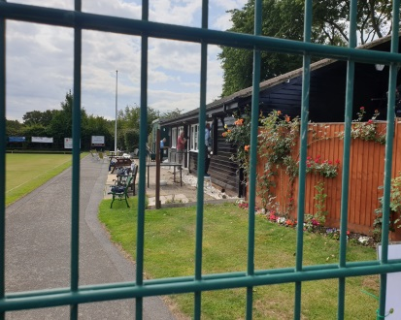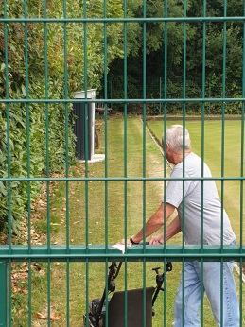
SAFE BEHIND BARS PERMANENT INMATE
Like all motley crews they have to be fed,
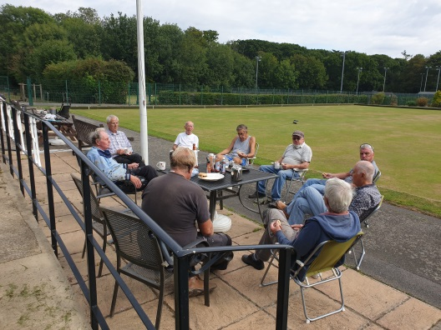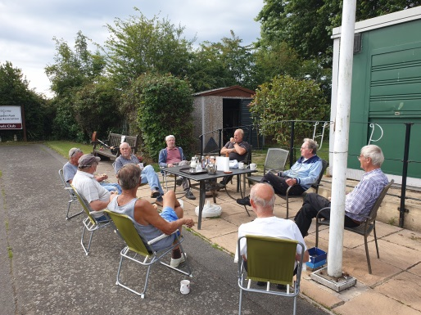
Sausage baps plus tea, they have never had it so good
After a lot of negotiation, managed to get them to work. If you recognize any of the mug shots below, please thank them for their work to keep them happy
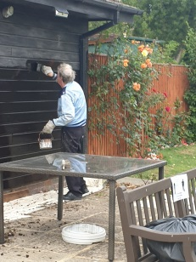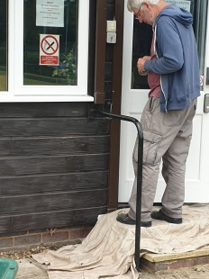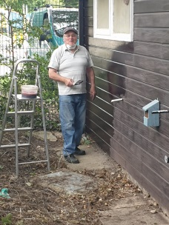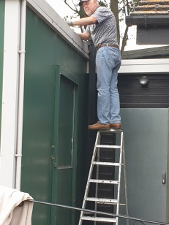
THE BRUSH OFF ARTIST THE GAFFER TAPER THE ESCAPED GNOME THE ELOPER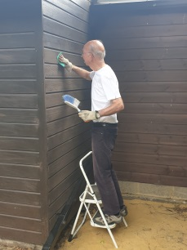 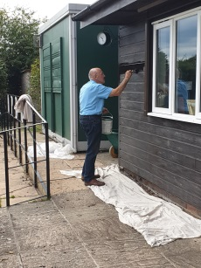 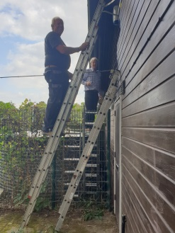
THE SCUFFER THE EXTRA TWO LOOKOUTS

Seriously they have all done a great job of painting our clubhouse. On behalf of the members we all say THANK YOU A great job well done. Did release them when the sentence was up.

