Abdon & Heath Parish Council
Marquee for hire only £65 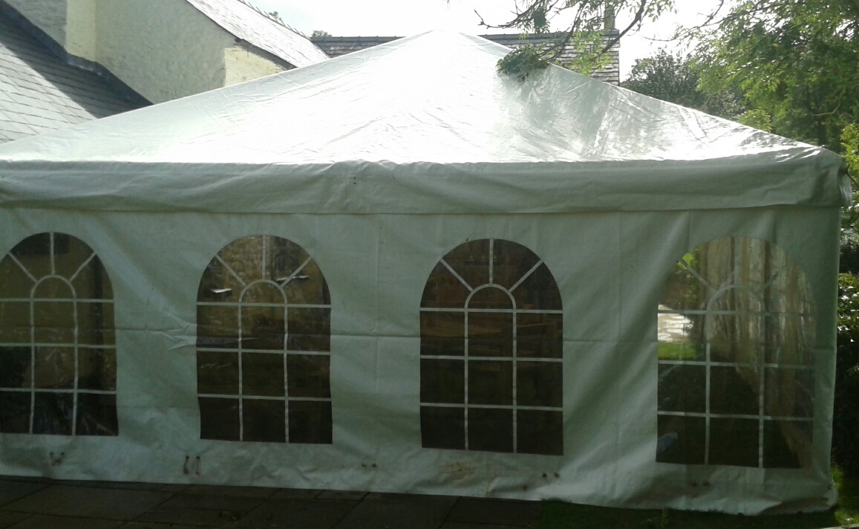
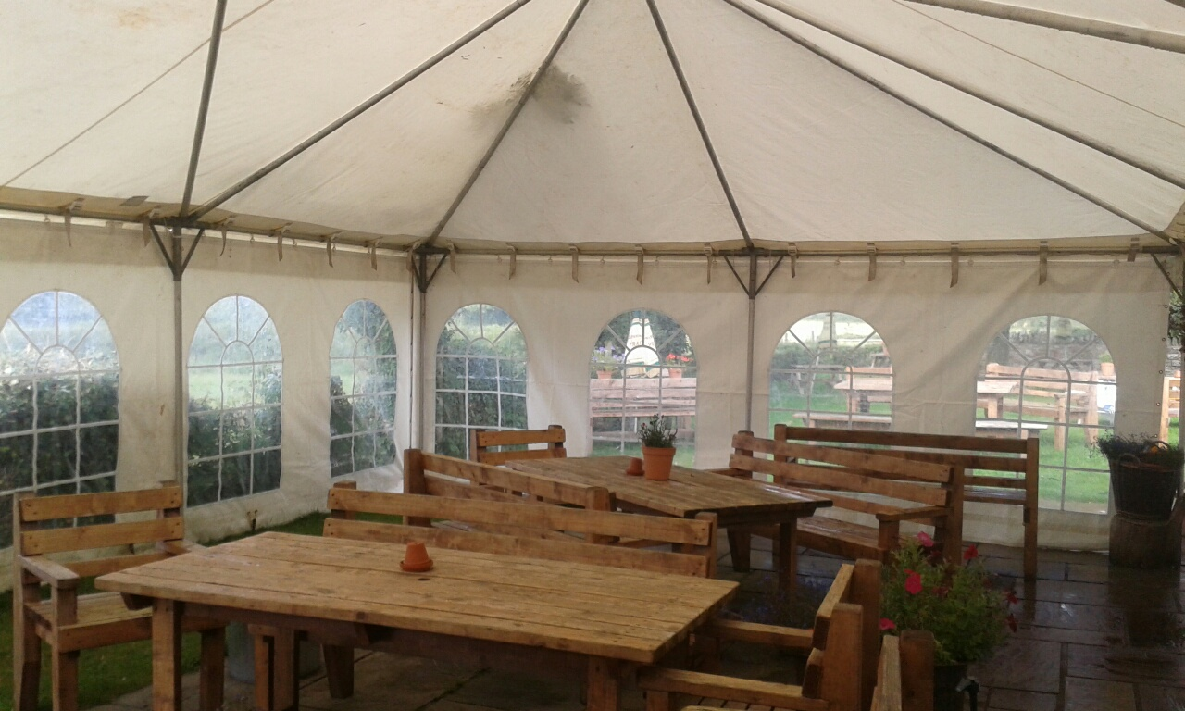
30’ x 20’
Choice of solid sides or windows
Ideal for parties & Family get togethers
Available 1st April- 30th Sept.
Tel: 01584 823 678 Evenings
Abdonandheathclerk1@outlook.com

Abdon & Heath Parish Council
Marquee for hire only £65
30’ x 20’
Choice of solid sides or windows
Ideal for parties & Family get togethers
Available 1st April- 30th Sept.
Tel: 01584 823 678 Evenings
Abdonandheathclerk1@outlook.com

Abdon & Heath Parish Council
Marquee for hire only £65
30’ x 20’
Choice of solid sides or windows
Ideal for parties & Family get togethers
Available 1st April- 30th Sept.
Tel: 01584 823 678 Evenings
Abdonandheathclerk1@outlook.com

Abdon & Heath Parish Council
Marquee for hire only £65
30’ x 20’
Choice of solid sides or windows
Ideal for parties & Family get togethers
Available 1st April- 30th Sept.
Tel: 01584 823 678 Evenings
Abdonandheathclerk1@outlook.com

