STANTON LACY PARISH COUNCIL
You are summoned to attend a meeting of Stanton Lacy Parish Council at 7.30pm on Thursday 21st January 2021 via Zoom
Meeting ID: 837 2838 3686 Passcode: 261753 (details on Parish website)
Members of the public are welcome to join the meeting.
Signed: 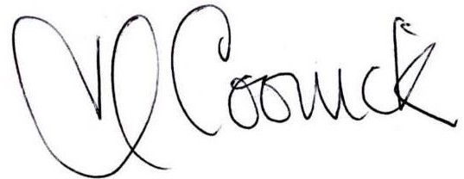 (Parish Clerk) Date: 15th January 2021

AGENDA
- Apologies for absence and acceptance of apologies (please notify the Clerk prior to the meeting)
- Declarations of Interest and Dispensations: The Council will receive disclosures of personal and prejudicial interests from Members on matters to be considered at the meeting. The disclosure must include the nature of the interest. If an interest becomes apparent to a member during the course of the meeting that has not been disclosed under this item, the member must immediately disclose it. Members may remain in the meeting and take part fully in discussions and voting unless the interest is prejudicial. Dispensations received in writing to the clerk, or verbally at the meeting will be considered.
- Public involvement session. Members of the public are able to ask a question or make a statement. If it is not possible to respond at the meeting, a written response will be provided at a later date.
- Approve the minutes of the ordinary meeting on the 19th November, 2020.
- Reports From Representatives:
  - Shropshire Council - Cllr Cecilia Motley
- Finance:
  - Approve the finance report/ bank reconciliation/ forecast of expenditure.
  - Agree and adopt the budget and set the precept for 2021-2
  - Agree Environmental Maintenance Grant Application

- Update on the Preparation for the Elections in May 2021
- Update on the Census 2021
- Update on the Bus Shelter Relocation
- Agenda Items for the next meeting
- The next meeting to be held on 18th March, 2021 at 7.30pm.

Copies of the agenda and minutes are available from the Clerk, Heather Coonick:
www.stantonlacyparish.org email: stantonlacypc@gmail.com Tel: 07817607355

