STANTON LACY PARISH COUNCIL
You are summoned to attend a meeting of Stanton Lacy Parish Council at 7.30pm on Thursday 18th March 2021 via Zoom Meeting ID: 890 1334 2878
Passcode: 350855

Members of the public are welcome to join the meeting.
Signed: 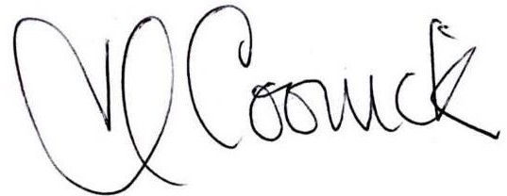 (Parish Clerk) Date: 12th March 2021

AGENDA
- Apologies for absence and acceptance of apologies (please notify the Clerk prior to the meeting)
- Declarations of Interest and Dispensations: The Council will receive disclosures of personal and prejudicial interests from Members on matters to be considered at the meeting.
- Presentation by Airband - Cancelled
- Public involvement session. Members of the public are able to ask a question or make a statement. If it is not possible to respond at the meeting, a written response will be provided at a later date.
- Approve the minutes of the ordinary meeting on the 21st January, 2021.
- Finance:
  - Approve the finance report/ bank reconciliation/ forecast of expenditure.
  - Payments: A Pritchard (consider part payment) Bus Shelter, Reimburse Clerk for stationary supplies.
  - Agree the Internal Auditor for 2021-2022

- Reports From Representatives:
  - Shropshire Council - Cllr Cecilia Motley
- Preparation for the Election in May 2021
- Review and Adopt Statement of Internal Control
- Agree the Neighbourhood Fund Report
- Decide upon a Contractor for the Minor Highways Grant
- Consider the option for an Electric Car Charging Point in the Parish
- Agenda Items for the next meeting
- The Annual Parish Council Meeting and Annual Parish Meeting to be held on 20th May, 2021 at 7.30pm.

Copies of the agenda and minutes are available from the Clerk, Heather Coonick:
www.stantonlacyparish.org email: stantonlacypc@gmail.com Tel: 07817607355

