SUTTON VALENCE PARISH COUNCIL

From the Clerk:
Mrs Janet Burnett E-mail: clerk@suttonvalence.org.uk The Parish Office Sutton Valence Village Hall Sutton Valence
Tel: 01622 844135 Maidstone
Web site: www.suttonvalencepc.kentparishes.gov.uk Kent ME17 3HS

Notice is hereby given of a meeting of the Parish Council to be held on Thursday July 8, 2021, at 7.00pm at the Committee room, Sutton Valence Village Hall when the following business is proposed to be transacted:
The Chairman to ask if anyone is recording
- Apologies for absence
- Declaration of lobbying
- Declaration of Changes to the Register of Interests
- Declaration of Interest in items on the agenda
- Requests for Dispensation
- Cllr resignation
- Deputy Clerk – job advertisement
- Finance
External Audit - Annual Governance and Accountability Return.
- The Parish Council to review the effectiveness of the system of internal control and resolve to approve the Annual Governance statement 2020/21
- The Parish Council to consider The Accounting statements 2020/21 and resolved to approve the Accounting Statement.
- Notice of the period for the exercise of public rights to be set.
- Appointment and scope of Internal Auditor
- Planning: Recommendation to be made on:
21/502229/FULL Oakdene Farm Maidstone Road ME17 3LS
Erection of packing area and storage building, drainage lagoon, relocation of existing agricultural workers caravans and landscaping. |

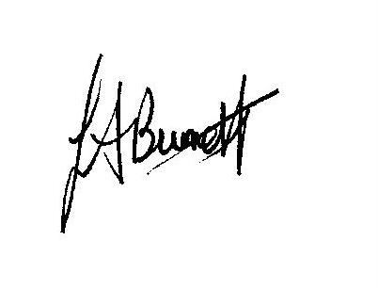

Janet Burnett – Clerk to the Council 4/7/21

