SUTTON VALENCE PARISH COUNCIL

From the Clerk:
Mrs Janet Burnett E-mail: clerk@suttonvalence.org.uk The Parish Office Sutton Valence Village Hall Sutton Valence
Tel: 01622 844135 Maidstone
Web site: www.suttonvalencepc.kentparishes.gov.uk Kent ME17 3HS

Notice is hereby given of a remote meeting of the Parish Council to be held on Thursday February 11th 2021 at 7.00pm when the following business is proposed to be transacted:
The Chairman to ask if anyone is recording
Submissions from Public, Police, Community Support Warden, County or Borough Councillors
- Apologies for absence
- Death of Peter Green a former long standing Councillor
- Declaration of lobbying
- Declaration of Changes to the Register of Interests
- Declaration of Interest in items on the Agenda
- Requests for Dispensation
- Minutes of the meetings held 14th and 28th January 2021 to be agreed
- Covid 19
- Electrical charging points
- Consultations
- KALC
- Website update
- Social media
- Training
- Data Protection
- Local Development Framework
- Neighbourhood Plan
- Website closure update
- Planning
- Recommendation to be made on the following applications:
- 21/500176/FULL - The Nest Maidstone Road ME17 3LS
Demolition of garden store. Erection of single storey rear extension and replacement garden store.
- 21/500105/FULL - Pancake Old Apple Store Boyton Court Road ME17 3BY
Change of use of from agricultural to residential garden, erection of carport with storage space above and creation of new access.
- 21/500516/FULL PROPOSAL: Langley Lodge Chartway Street ME17 3HX
Section 73 - Application for variation of condition 3 and minor material amendment to approved plans condition 2 (to allow change to materials) pursuant to 20/504237/FULL for - Partial demolition and reconstruction of existing garage outbuilding for use as a pool house, including replacement roof, pergola and external alterations. Creation of a swimming pool and internal and external alterations to existing storage outbuilding to allow use as a garage, including associated landscape works.
- Finance
    - Authorisation of payments
    - Bank Balances
    - Income
    - Expenditure
    - Direct Debit form for website
    - Bank Reconciliation
- Performance against budget

- Recreation and Open Spaces
- War Memorial Play Area and field
- Weekly and monthly inspections
- Annual Play area inspection – awaiting repairs
- Replacement fence – awaiting repairs
- Car Park
- Pavilion update
- Football
- Tennis Court resurfacing update
- Harbour Play Area and field
- Weekly inspection
- Monthly inspection
- Open Spaces
- Extension of Conservation Area
- Parish Council field in South Lane
- Tree survey
- Roads & Transport Group (inc. Lighting)
- Roads
- Speed Limit Order on Headcorn Road, Sutton Valence in the Borough of Maidstone
- Public Transport
- Lighting
- Allotment
Cllr Ward to report
- Police
- Correspondence
- Village Hall
- Agenda items for next meeting
- Date of next meeting

Janet Burnett – Clerk to the Council 5/2/21

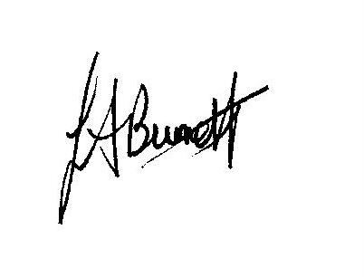

THIS MEETING IS TAKING PLACE REMOTELY ON ZOOM. IF YOU WISH TO ATTEND THE MEETING PLEASE
JOIN USING THE DETAILS BELOW

https://us02web.zoom.us/j/89397694960

