To all Great Milton Parish Councillors:

You are summonsed to attend a PARISH COUNCIL MEETING on Monday 19th March 2012 at 7.30pm in the Pavilion:

26/12 Apologies for Absence
To receive apologies for absence from the meeting.

27/12 Register of Interests for this Meeting
To receive declarations of interest in matters on the Agenda.

28/12 Minutes of the Previous Meeting
To approve and sign minutes of the PC meeting held Monday 20th February 2012.

29/12 Matters to Report
To receive updates from the neighbourhood policing team, District and County Cllrs, the Clerk and receive progress reports (not appearing as agenda items), including:

A Facilities for Young People in Great Milton
B Progress with Parish Council Action List

30/12 Correspondence and Public Discussion
To take questions from the public and receive items of correspondence.

31/12 Planning Applications
A To consider the following Planning Application:
Farriers Cottage, Church Road, Great Milton, OX44 7PB. P11/W2334. Two storey extension to rear of property to provide ground floor cloakroom off family room and ensuite bathroom at 1st floor level. Single storey extension to side of property to provide utility room and playroom.

B To consider the following Planning Appeal:
Land East Crowthorne Kennels, Milton Common, OX9 2JX. Appeal reference number:
APP/Q3115/A/12/2170888/NWF. Erection of a fence and gates up to 2.4 m high and three storage buildings. (As amended by site plan and location plan received 26 August 2011).

C To review any planning decisions received and any outstanding planning matters.

32/12 Village Maintenance
To review the estimates provided by Dave Pullen for painting the posts on the Green outside The Bull (£150) and for improvements to the Sandy Lane Bus Shelter (£150 plus materials) and agree the expenditure.

33/12 Diamond Jubilee Celebrations
To consider making a financial contribution to the street party and whether to purchase Jubilee products or memorabilia for sale on the day.

34/12 Dog Bin for Track to Allotments
To consider a request from residents for an additional dog bin for the track leading to the allotments and agree expenditure (£81.00 Ex VAT as per the bin for Grove Lane).

35/12 Web Site and Data Review
To consider web company Mh-p Internet’s invitation to join its loyalty scheme, to review the current provision and any future requirements. To review the requirements of the Information Commissioner’s Office with regard to the Freedom of Information Act and the Data Protection Act and ensure that the Parish Council is the correct procedures in place.

36/12 Financial Resolutions
A To authorise the following cheques for payment and to sign the related invoices:

Joanna Botha. February salary. £322.18.
Joanna Botha. Bulletin advertising overtime. (6 hours x £8.747)
Jonathan Dudley. Bulletin Production. TBC
MP Printers. Parish Plan Production – 500 copies. £846
ICO. Data Protection Notification fee. £35
OALC. Annual subscription. £133.07
Oxford Greenbelt Network. Annual subscription. £15
BT Payphones. Kiosk sponsorship. £360
Church Clock Servicing. £202.80
Churchyard Grass Cutting Grant for PCC. £500
Windmill Landscapes. Hedge Cutting. £180.00
SODC. Dog bin emptying Oct-Dec 2011. £36.60
Dave Pullen. Village Maintenance – clearing gullies, vegetation and erecting dog bin. £450
Three Village Hospital Car Service volunteers. Reimbursements for fuel. £66 in total.
Sylvia Kirby. Reimbursement for car service phone calls. £6

B To review the effectiveness of internal controls including a revised risk management document and the level of fidelity guarantee insurance cover.

37/12 Any Other Business
This part of the meeting may be used to bring the Clerk’s attention to village maintenance issues, inform the meeting of any notices or diary dates and to propose future agenda items.

All members of the press and public are very welcome at this meeting. The date of the next Great Milton Parish Council meeting will be Monday April 16th 2012 starting at the earlier time of 7pm, followed by the Annual Parish Meeting at 8pm. Both meetings will be held in the Pavilion.

Signed: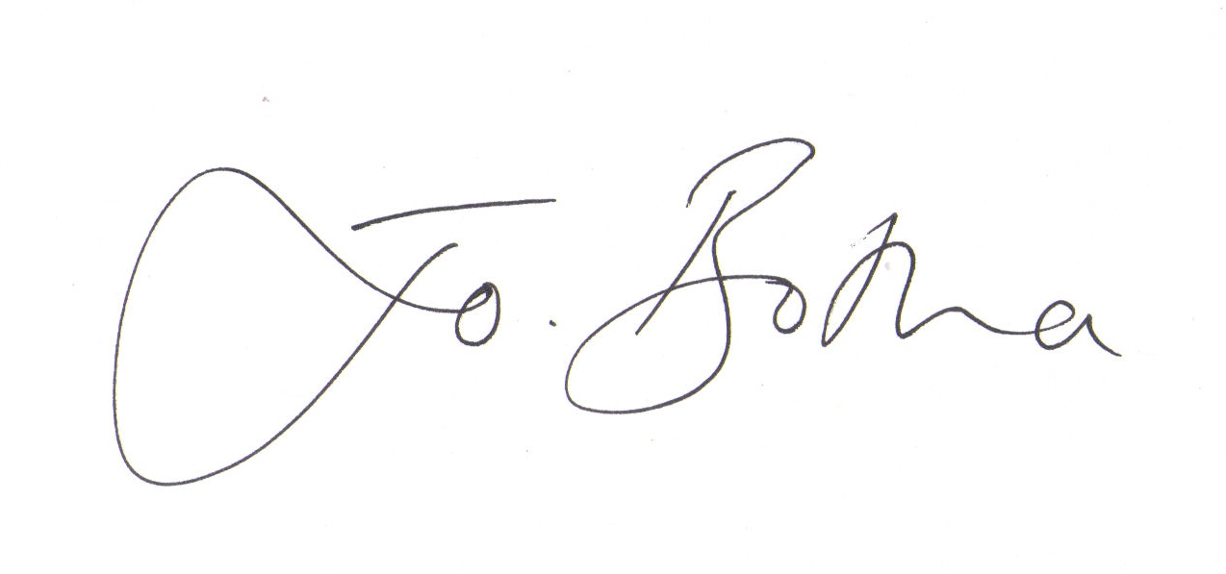

Joanna Botha
Clerk/Responsible Financial Officer

