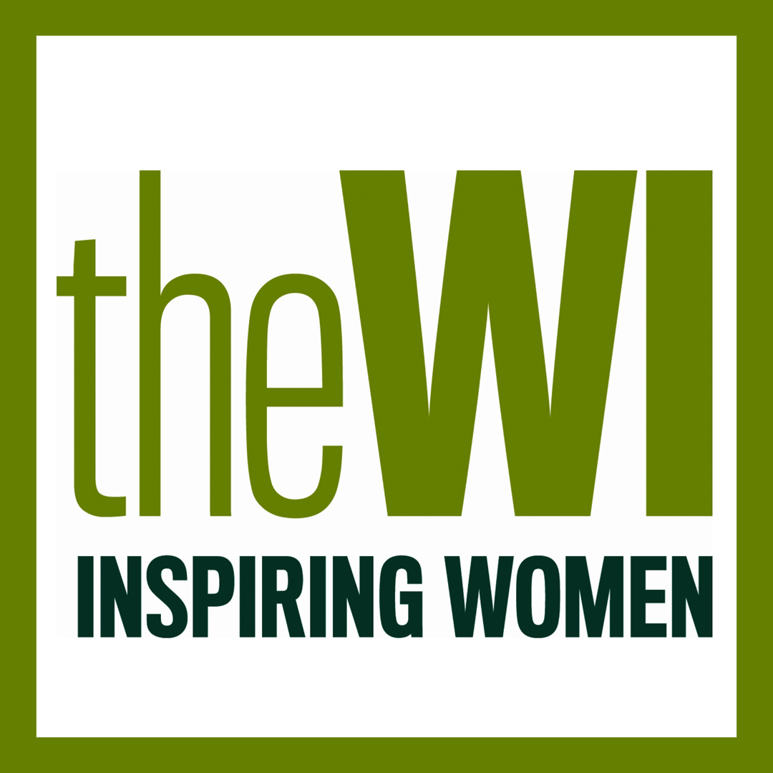

Halam WI
April 2021 Newsletter
Happy Easter
I hope you are all well.

Social Media
For those of you with access to the internet have you seen our new and improved web page https://www.hugofox.com/community/halam-nottinghamshire-10418/halam-wi and Facebook page https://www.facebook.com/Halam-WI-109697757845803? Katie has been working really hard on updating these sites with a view that not only does it keep all our current members up to date with what’s happening at our WI but also potential new members can see what we do too.

Photograph and Video Consent form
As Katie will be updating the web page and Facebook after each meeting, we thought it would be a good idea to also update the photography and video consent forms. I would be really grateful if you complete the form in the attachments and either email or post it back to me a soon as possible.

Subscriptions
Subscriptions are now due. Please forward payment of £22.40 by either cash or cheque (payable to Halam & District WI) to Katie, Willow House, School Lane, Halam, NG22 8AD. Thank you.

Programme for the rest of the year
June 8th – Get together for tea and cake at The Milkshed, Radley Rd
July 6th – A treasure hunt round Halam village
August 3rd – TBC
September 7th – An introduction to essential oils
October 5th – Bras and breast health
November 2nd – Christmas crafts
December 7th – Christmas party
January 4th – No meeting
February 1st – AGM

Please note these dates are all subject to Covid restrictions being eased and we may have to adjust meetings/activities depending on the rules at the time.

. NOTTINGHAMSHIRE FEDERATION OF WIs
A “CREATIVE ACTIVITIES” CHALLENGE:
WRITE A POEM ON THE THEME OF
FREEDOM
It’s coming. It’s not here yet, but it’s coming…. Freedom
We are challenging you to write a poem about freedom. It can rhyme or be free verse.
Freedom comes in many different guises – getting a job done, a breath of fresh air, going for a walk, being by the sea, an escape to somewhere else. So, share, in a poem, your thoughts on freedom.

Closing date 30th June 2021
Send by post to County House or
email:admin@nottswi.org.uk ref freedom poem in subject box

