STANTON LACY PARISH COUNCIL
You are invited to attend a meeting of Stanton Lacy Parish Council at 7.30pm on Thursday 19th November 2020 via Zoom
Meeting ID: 865 1994 9800 Passcode: 600332 (details on Parish website)

Members of the public are welcome to join the meeting.
Signed: 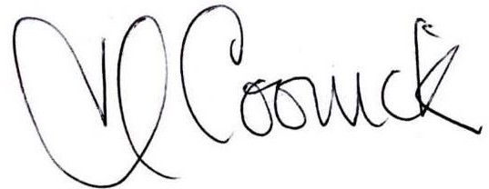 (Parish Clerk) Date: 13/11/2020

AGENDA
- Apologies for absence and acceptance of apologies (please notify the Clerk prior to the meeting)
- Declarations of Interest and Dispensations: The Council will receive disclosures of personal and prejudicial interests from Members on matters to be considered at the meeting. The disclosure must include the nature of the interest. If an interest becomes apparent to a member during the course of the meeting that has not been disclosed under this item, the member must immediately disclose it. Members may remain in the meeting and take part fully in discussions and voting unless the interest is prejudicial. Dispensations received in writing to the clerk, or verbally at the meeting will be considered
- Public involvement session. Members of the public are able to ask a question or make a statement. If it is not possible to respond at the meeting, a written response will be provided at a later date.
- Approve the minutes of the Ordinary meeting held on the 17th September, 2020.
- To receive an update on Broadband on The Hope from the Clerk/RFO
- Adopt ‘Governance and Accountability’ document.
- Decide on the response to Shropshire Climate Action Partnership (SCAP) request for evidence and their offer to attend a Parish Council meeting.
- Decide upon nomination to Her Majesty’s Lord-Lieutenant of Shropshire Garden Party for Community Support during Pandemic.
- Agree meeting dates for 2021
- Finance:
  - Approve the finance report and bank reconciliation
  - Decide whether to accept the new NJC 2020-21 Salary award of 2.76% from 1st April 2020 for the Clerk/RFO.
  - To approve the forecast of expenditure.
  - To consider the proposed budget for 2021-22 to be formalised at January 2021 meeting.
  - Decide whether to apply for the Environmental Maintenance Grant for 2021-22 on the same conditions as the present grant.
  - To consider donations to Shropshire MIND, Hope House Children’s Hospice, Citizens Advice Bureau
  - To decide upon thanks to website volunteer.

- Reports From Representatives:
  - Shropshire Council - Cllr Cecilia Motley

- Planning:
  - To decide upon response to: 20/04424/VAR The Thatches, 1 Vernolds Common, Craven Arms, Shropshire, SY7 9LP Variation of condition 3 (restricted use of building) pursuant of 18/05279/FUL to allow for conversion and use of first floor of approved garage building as a holiday let property
- Agenda Items for the next meeting
- The next meeting to be held on 21st January, 2021 at 7.30pm.

Copies of the agenda and minutes are available from the Clerk, Heather Coonick:
www.stantonlacyparish.org email: stantonlacypc@gmail.com Tel: 07817607355

