The Worldham VE Day 75 Event this weekend has been postponed but a celebratory Event will be
held when the “new normal” allows.
There’s lots going on this Friday 8th May for Stay at Home celebrations. Its been suggested that
there’s a nationwide Doorstep Sing Along of “We’ll Meet Again” after the Queens speech at 9.-00pm.
So, let’s put the bunting out and get singing.
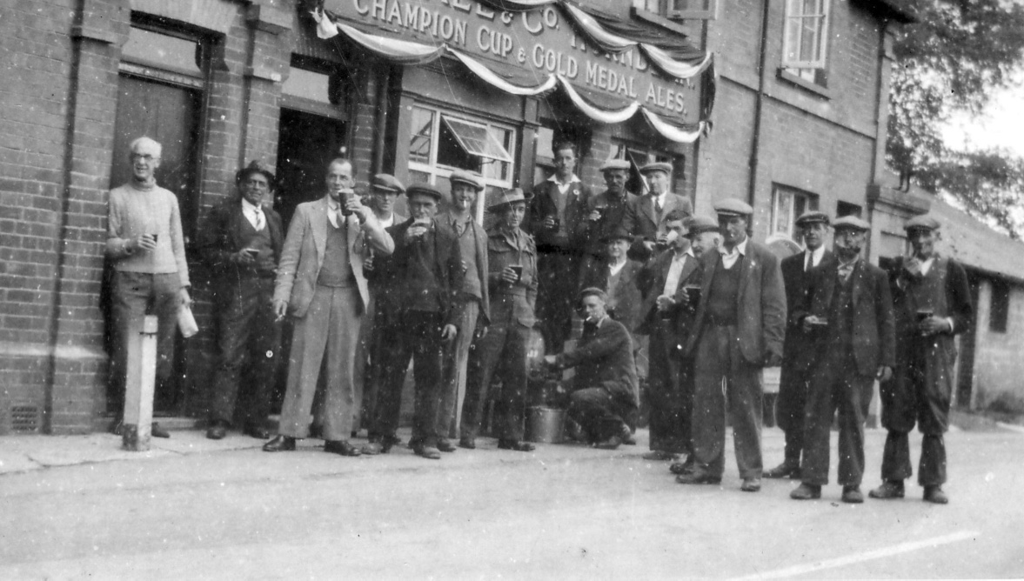
Photo courtesy of the East Worldham History Archive VE Day at the Three Horseshoes 1945

