SUTTON VALENCE PARISH COUNCIL
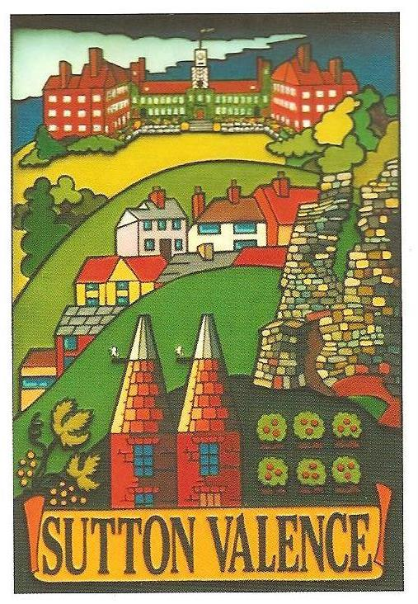
From the Clerk:
Mrs Janet Burnett E-mail: clerk@suttonvalence.org.uk The Parish Office Sutton Valence Village Hall Sutton Valence
Tel: 01622 844135 Maidstone
Web site: www.suttonvalencepc.kentparishes.gov.uk Kent ME17 3HS

Notice is hereby given of a meeting of the Parish Council to be held at the Village Hall on Thursday October 14th at 7:00pm when the following business is proposed to be transacted:
The Chairman to ask if anyone is recording
Submissions from Public, Police, Community Support Warden, County or Borough Councillors
- Apologies for absence
- Declaration of lobbying
- Declaration of Changes to the Register of Interests
- Declaration of Interest in items on the agenda
- Requests for Dispensation
- Minutes of the meetings held 13th July, 9th and 30th September 2021 to be agreed and signed
- Employment of deputy Clerk and salary to be considered in closed session
- Coffee morning
- Welcome Back Fund
- Memorial garden
- Independent School meeting
- Electrical charging points
- Consultations
- KALC
- Newsletter
- Platinum Jubilee celebrations 2022
- Coffee morning
- Training
- Laptop purchase to be ratified
- Planning
Recommendations to be made on:
- 21/505239/FULL 9 The Platt ME17 3BQ
Demolition of existing garage and erection of a two-storey side extension (revised scheme to 21/503549/FULL)
- 21/504509/LBC Farthing Green Farm New Barn Road Hawkenbury TN12 0EE
Listed Building Consent for replacement of 5no. modern timber windows and doors to south and west elevations, with bespoke timber windows and doors maintaining existing openings.
- 21/504757/FULL Little New Barn Farm New Barn Road Hawkenbury TN12 0ED
Siting of 5no. holiday pods, erection of small pole barn to house 1no. portable shower block and 1no. portable WC block, construction of waste compound and temporary access road and paths.
- Finance
    - Authorisation of payments
    - Bank Balances
    - Income
    - Expenditure
    - Bank Reconciliation
- Performance against budget

- External Audit
- Conclusion of audit
The smaller authority failed to approve the AGAR in time to publish it before 1 July 2021, the date required by the Accounts and Audit Regulations 2015 and did not disclose this by answering ‘No’ to Section 1, Box 1.

- Other matters
We note that the smaller authority did not comply with Regulation 15 of the Accounts and Audit Regulations 2015 as it failed to make proper provision during the year 2021/22 for the exercise of public rights, since the period for the exercise of public rights did not include the first 10 working days of July. As a result, the smaller authority must answer ‘No’ to Assertion 4 of the Annual Governance Statement for 2021/22 and ensure that it makes proper provision for the exercise of public rights during 2022/23.
- The Parish Council to note the AGAR result
- Recreation and Open Spaces
- War Memorial Play Area and field
- Weekly and monthly inspections
- Annual Play area inspection
- Car Park
- Pavilion update
- Working party to be formed and terms of reference to be agreed
- Football
- Tennis Court
- Resurfacing update
- Harbour Play Area and field
- Weekly inspection
- Monthly inspection
- Annual inspection
- Open Spaces
- Extension of Conservation Area
- Land at The Harbour at the rear of parishioner’s garden to be discussed.
- Tree survey
- Roads & Transport Group (inc. Lighting)
- Highways Improvement Plan – Schemes to be prioritised
- Roads
- Remembrance Sunday
- Lighting
- Allotment
- 2020/21 allotment fees to be agreed
- Police
- Correspondence
- Village Hall
- Agenda items for next meeting
- Date of next meeting

Janet Burnett – Clerk to the Council 7/10/21

