Stanton Lacy Parish Plan
2017

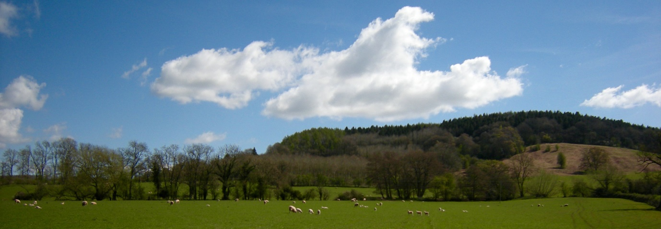

Summary
The Parish Plan for Stanton Lacy Parish is based on the responses of the residents of the Parish, in a survey undertaken in 2013. The survey was designed to establish what the resident’s opinions were about the Social, Economic and Environment issues relating to and at Parish level in relation to the future needs/aspiration of the Parish
Key issues which emerged are:
- Broadband speeds and mobile phone coverage are consistently very poor across the whole Parish area; this is likely to adversely impact economic sustainability and development in the Parish.
- No local services available (assumed to be in relation to Health etc).
- A desire for some small to medium sized housing was identified, with redevelopment of derelict sites seen as a preferred solution.
- Improved local communication required - being addressed through the Parish website, Village Hall Facebook page and improved notice board displays.
- The need to provide for access and upkeep to the local environment
- The need to assist in the provision/support for increased leisure and social activities within the Parish
The Plan confirms the desires and future needs as perceived by the residents of the Parish. The Plan should be used as a guide / roadmap by those wishing to become a part of the community, or to make changes to/within the Parish, or those administering the Parish at local or County level.
The Parish Council will undertake an annual review of plan progress and instigate updates to the plan as necessary. This will be reported at the Annual Parish Council Meeting.

Background
The Core Strategy Development Plan adopted by Shropshire council in 2011 is a key part of the Shropshire Local Development Framework and sets out how Shropshire is expected to evolve over the period to 2026.
This Parish Plan will enable the Parish Council to respond to consultations and planning applications based on the views, wishes, needs and opinions of the whole community to cover the social, economic and environmental issues that are relevant to the community.

Parish Setting and Demographics
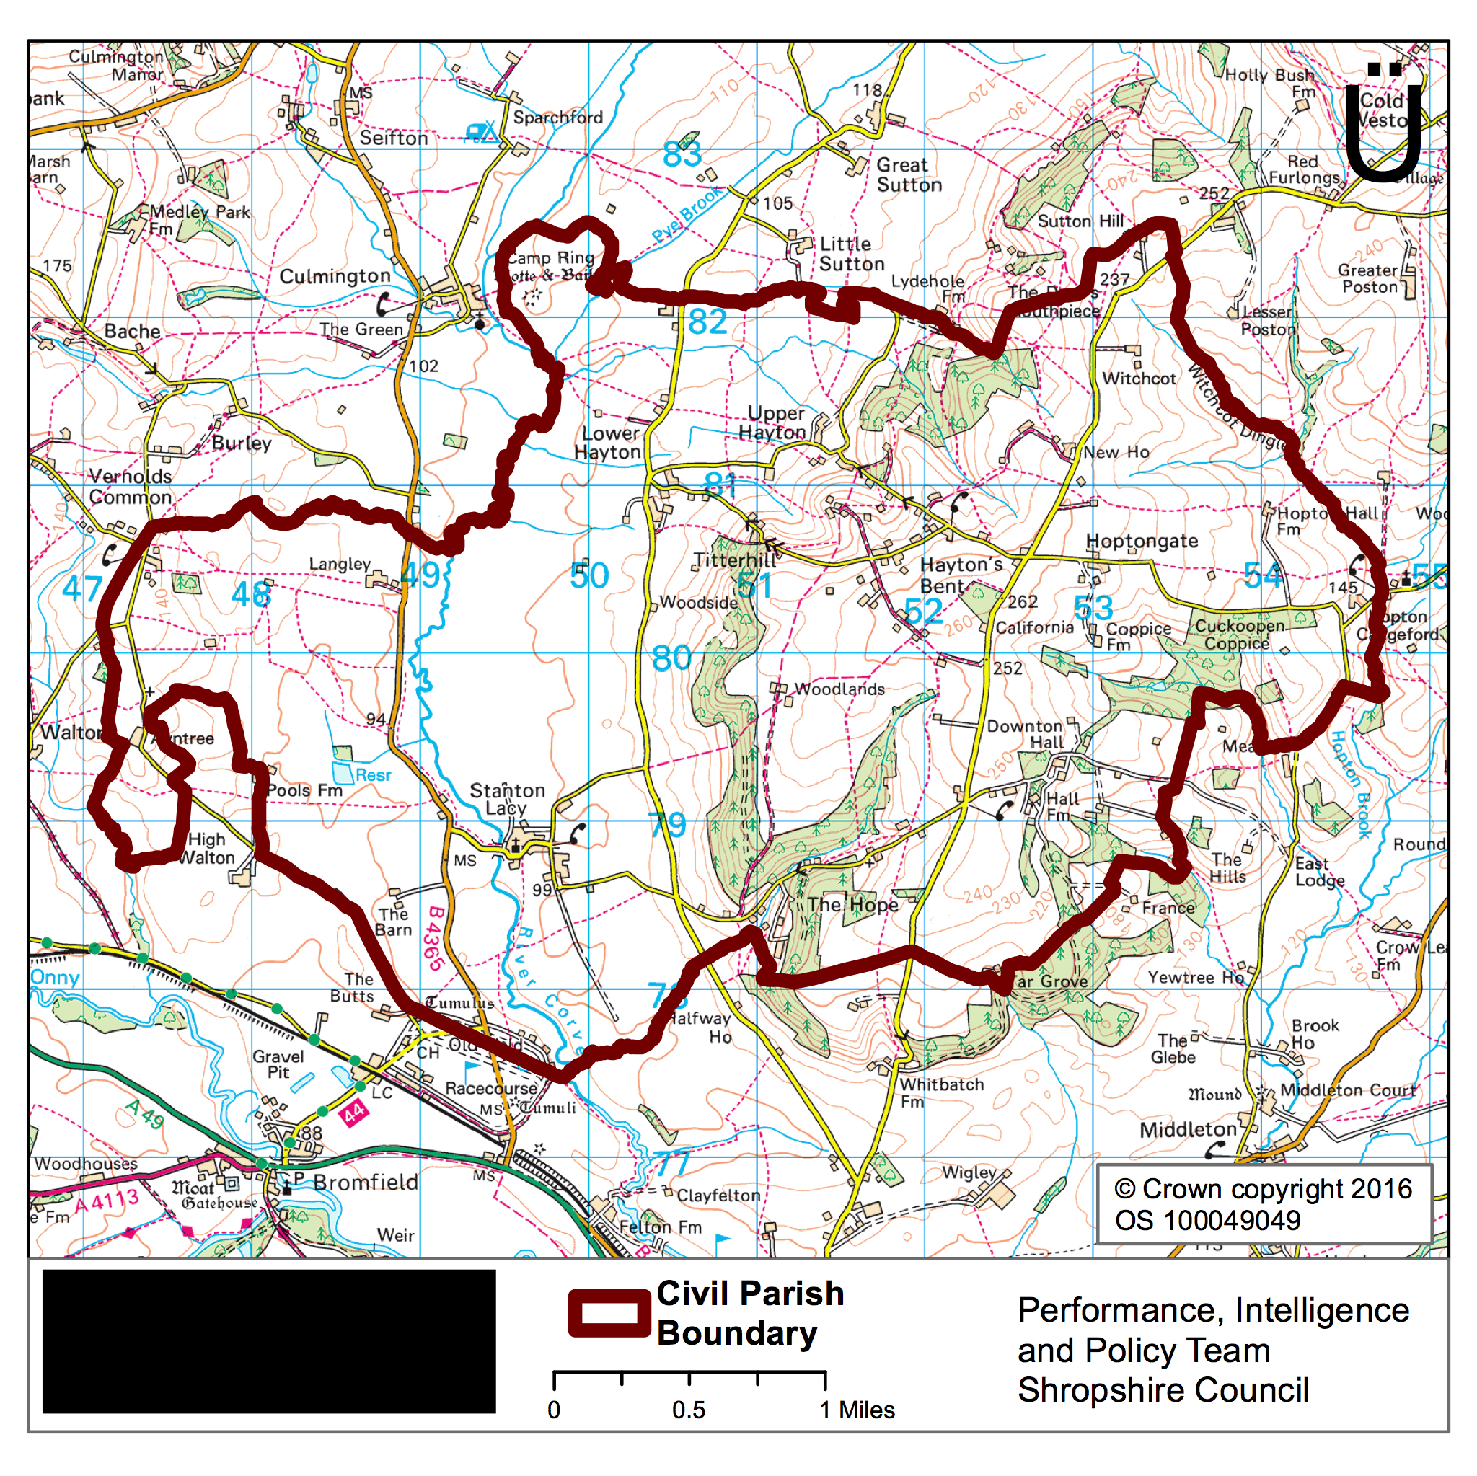

Stanton Lacy Parish is located in South Shropshire, some 2km north of Ludlow. The parish is rural in nature and covers 9 square miles, the majority of which is within the Shropshire Hills Area of Outstanding Natural Beauty (AONB).
The Parish is still largely agricultural, made up of the village of Stanton Lacy and small settlements that include:
- Vernolds Common (part of)
- The Hope
- Lower Hayton
- Upper Hayton
- Hayton's Bent - location of Stanton Lacy Village Hall
- Downton
- Hopton Gate
- Hopton Cangeford (part of)

Demographics

According to the 2011 census there were 345 people living in the parish. There were 28 people aged between 20-29 a prime age group for moving out from parental homes and needing accommodation. There were also 29 children recorded.
Most properties are privately owned but just under a third are privately rented. 210 people between the ages of 16-65 are in employment 80 of whom are self-employed. 39 households have at least one person who has a long-term health condition and 14 people are providing unpaid care (usually to a family member) of more than 20 hours per week
Housing and Development
The Parishioners believe there is a need for additional housing in the parish over the next 5-10 years. The perceived need is for 5-10no. small and medium sized houses (1-3 bedrooms), being a mix of Affordable and privately developed homes, preferably as single developments.
Locations need to be mapped for protection from development and for development, with strong support for development of derelict sites (88%), and general support for infill in existing settlements. Generally, there is opposition to new housing when in clusters, particularly in the AONB.
All new development should be in accordance with the planned Stanton Lacy Parish Plan Design Guidelines, as determined by the Community and the Parish Council.

There are 22no. Grade 2 listed buildings in the parish plus the Grade 1 St Peters Church and 4 other items on the National Heritage list (milestone, war memorial, a barrow and a camp ring) which should be preserved as part of the heritage of the Parish.
The Community and Parish Council will be supportive of applications that are for single or small numbers of 1-3 bedroom dwellings in the local styles, particularly if they include the redevelopment of existing (derelict) sites.

Telecommunications
Improvements to the availability and speed of the existing telecommunications services in the Parish are required, to support and assist existing users in the Parish, as well as encouraging further development/occupation from users that include home-based businesses, while remaining cost effective. The term telecommunications includes both broadband internet service as well as the service provided by mobile phone companies.

Local Communication
Residents of the Parish wish to be informed on council activity, social events, broadband issues, local road works etc via the Parish website (www.stantonlacyparish.co.uk) as well as by the traditional Notice Boards.

Environment Access and Safety
The maintenance of the existing environment is very important to the Parish Residents, mostly relating to roads, but also including issues such as hedgerows, footpaths, street lighting and litter. Residents wish to see the establishment of a Resident's Partnership for monitoring such issues, as well as such issues as signing and way marking, gates, stiles, bridleways, footpaths, road names and passing places. Such a scheme should have a system of reporting to Shropshire Council
In general, residents do not currently use public transport, nor do they feel a community managed transport scheme would be of benefit to them.
There are some reservations about increased tourism in the Parish, but with some support for Footpaths, Views and the Church being potential visitor attractions.
A significant number of Residents are interested in joining a Neighbourhood or Farm Watch scheme.

Utilities and Sustainability.
Generally, there is support for small-scale wind and solar energy generation, in the Parish. Any scheme would be expected to comply with the Parish’s ‘requirements’ for any new development, as may be detailed in the Parish Plan
The provision of one or more recycling points in the Parish is desirable, with the Village Hall being the most suggested location.
Generally, the Residents of the Parish have confirmed that they wish to retain and maintain the public telephone boxes in the Parish, but not necessarily as telephone boxes.
Health and Social Care
It is suggested that there should be an Annual review of the Parish Plan to establish if there are general health access concerns which need to be raised with providers.

Leisure and Social Activities
The community enjoys a range of leisure and social activities currently offered and would like to see the range expanded with suggestions that include Keep Fit, IT, Photography and First Aid, Films or ‘Flicks in the Sticks’ etc initiatives would all be encouraged and supported.

REVIEW:

The Parish Council will review the progress made towards achieving the goals/wishes etc identified by the residents of the Parish, and will assist in actioning items and updating of the plan, as needed, on an annual basis. It is intended that the Annual Review and update will be reported at the Parish Council Annual Meeting.

