2016 to 2026
Area: 3.97ha
NGR: SK 649560
10 year Woodland Management Plan for Millennium Wood, Farnsfield, Nottinghamshire.

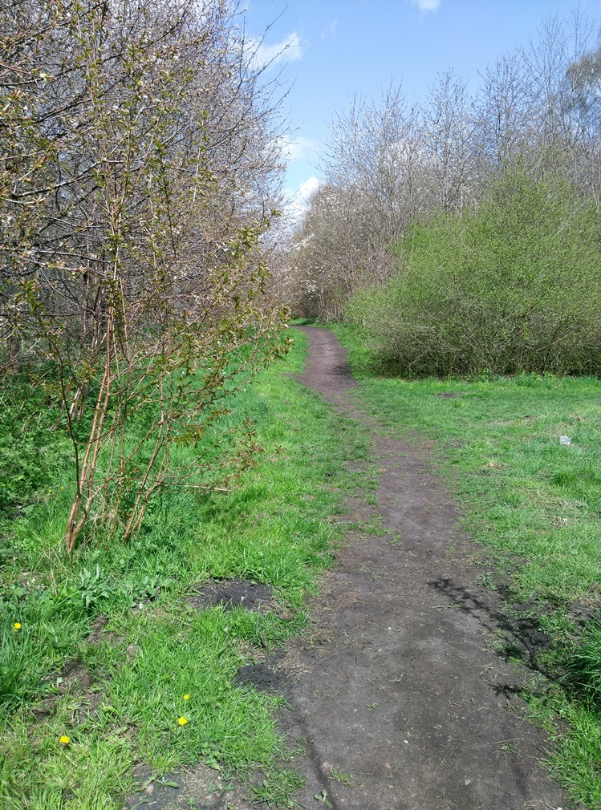

Woodland Property Name | Millennium Wood
Unique Reference | URN 00151
Plan Period 29/09/16 (ten years) | Approval Date: 29/09/16 | To: 28/09/16
Five Year Review Date | August 2021
Approval Criteria – FC Office Use Only
The UKFS states that a management plan should:
UKFS | Approval Criteria |  | FC Approval & Notes
State the objectives of management, and how sustainable forest management is to be achieved | Have objectives of management been stated? Consideration given to economic, environmental and social factors (Section 2.2) |  | Yes all considered a small wood well used by the community
Provide a means to communicate forest proposals and engage interested parties | Have work proposals been communicated in the management strategy (section 5) and felling & restock table (section 7) and potential interested parties identified in Section 5 |  | Yes, as per guidance of the applicant. May need to put in stand -alone FLA if Ash disease progresses
Serve as an agreed statement of intent against which implementation can be checked and monitored | Has a five -year review period been stated below, and achievements recorded in section 3 |  | Yes
Approving Officer Name | C Reynolds | Plan approved 29/09/16 |  | Yes

- Property Details
Name | Farnsfield Parish Council |  | Owner |  | Yes
Email | info@farnsfield-pc.uk |  | Contact Number |  |  | 01623 882884
Address | The Village Centre,  New Hill,  Farnsfield, Newark.  Nottinghamshire.  NG22 8JN
Agent Name (if applicable) |  |  | Steve Vessey
Contact Number |  | 07719143011 | Email | Steve.vessey73@gmail.com
County |  | Nottinghamshire | Nearest Town |  |  | Farnsfield
Grid Reference |  | SK647558 | Local Authority |  |  | Newark & Sherwood
Management Plan Area (Hectares) |  |  | 3.97ha
List the maps associated with this management plan |  |  | - Location  - Designations  - Habitats  - Compartments  - Machine access  - Constraints
Do you intend to apply for a felling licence with this management plan? |  |  | Yes
Declaration of management control and agreement to public availability of the plan |  |  | Yes
- Vision and Objectives
To develop your long- term vision, you need to express as clearly as possible the overall direction of management for the woodland and how you envisage it will be in the future.
2.1 Vision
Describe your long term vision for the woodland(s).
This woodland will be managed to ensure its continutiy within the landscape, whilst improving timber potential and conservation values.

The woodland is quite small and relatively young. Because of this, light silvicultural thinning to a marginal intensity over a 5 to 10 year cycle will be carried out to increase growth, increase light levels reaching the woodland floor, reduce the chance of windblow and increase future potential.

The woodland will be managed to allow continued access for the enjoyment of local people.

All works will endevour to improve the habitat for all wildlife.

Due to the size of the produce and location, the use of low ground pressure small forestry machinery will be utilised within all thinning operations.

Grant funding will be sourced where possible to help in the management of the site including The Woodland Trust and Forestry Commission.

2.2 Management Objectives
State the objectives of management, and how sustainable forest management is to be achieved. Objectives are a set of specific, quantifiable statements that represent what needs to happen to achieve the long- term vision.

No. | Objectives (including environmental, economic and social considerations)
1 | LANDSCAPE.  Manage and maintain the woodlands as an important landscape asset close to the village limits of Farnsfield.
2 | BIODIVERSITY.  Manage and enhance the environment to improve the habitat for woodland dwelling species including badgers and barn owls, by increasing the understory, allowing light to the woodland floor and maintaining standing and fallen deadwood throughout. New woodland blocks to be planted for both wildlife and to increase the fuelwood available on site.
3 | PROTECTION.  Deer, squirrels and rabbits/hares are at the moment slowly increasing within the area and unchecked will reduce the quality of viable future timber and natural regeneration within the woodland. These will need to be controlled and/or excluded to reduce and reverse this trend into the future. Pests and diseases will continue to be an issue moving forward, but will be looked at again if and when they become an issue.
4 | COMMERCIAL.  The woods will be managed if possible on a self-financing basis through the production of fuelwood grade timber in the main for use on site and work toward becoming carbon neutral. Though through careful management, there is potential to produce high quality timber for milling in the future. Grant funding will be secured where possible to support uneconomical management operations and appropriate infrastructure investments. If possible income will be generated from the sequestration of carbon and the trading of carbon credits.

- Plan Review - Achievements
Use this section to identify achievements made against previous plan objectives. This section should be completed at the 5 year review and could be informed through monitoring activities undertaken.

Objective | Achievement
Landscape | First 5yr cycle completed Sept 2020.It was in fact a 4 yr cycle because of available SANGS funds. Light thinning of trees
Biodiversity | Bulbs Planted Oct 2018,2019and planned for 2020 Norway maple saplings removed Oct. Cherry saplings removed from Western footpath by volunteers Oct 2020
Protection | Meadow area reinstated with cherry saplings removed by volunteers. Planned maintenance to cut meadow area annually and remove thatch. Grants from NSDC tree fund resulted in thickening up hedgerow and trees planted in adjoining areas in woodland. Habitats for birds/bats improved with introduction of bat boxes and bird boxes including Barn Owl Box in the meadow area
Commercial | Logs sold for timber but little removed. Covid 2019/20. Used for habit and wildlife colonisation.Deadwood

- Woodland Survey
This section is about collecting information relating to your woodland its location, including any statutory constraints: designations, European Protected Species etc.
  - Description
Woodland information for your property can be found on the Magic website or the Forestry Commission Land Information Search.
Brief description of the woodland property | Millennium Wood is situated to the south of the village of Farnsfield approximately 5km northwest of Southwell and 11km southeast of Mansfield in Nottinghamshire.  The site was formerly an agricultural field close to the sports ground in the village, and was planted to celebrate the Millennium in 2000.  The woodland in the main was planted at 2.5m x 2.5m spacing with predominately native broadleaves consisting of oak, lime, ash, wild cherry, silver birch, Norway maple, field maple and rowan. The woodlands are visible from the village and in the wider landscape.  The soil here is a sandy loam over sandstone which is deep and neutral pH to slightly Acidic. The woodland sits on the 50m contour above sea level. Wind-throw hazard classification is low due to the area and in the main would be classed as 1.  As Nottinghamshire is one of the UK’s driest Counties, the average rainfall is approximately 620mm per annum, with an average annual temperature of 10.58ºC.

- Strategy
This section requires a statement of intent, setting out how you intend to achieve your management objectives and manage important features and issues identified within the previous sections of the plan. The information provided should be succinct.

Mgt Objective/Feature | Outline Work Prescriptions/Operations | Year
Landscape | The woodland is visible from the village and from the surrounding countryside and is a popular place for local people to walk their dogs through. Careful management will be employed so not to alter this in any way. Light thinning to a marginal intensity will be carried out in 5 year ,cycles. | 2016 to 2026
Biodiversity | As the thinning takes place light will reach the woodland floor and increase the understory. This will be supplemented with the planting of shrubs, woodland flowers and shade-bearing tree species. Some of the cherry have suckered along the edges of the footpath, and most of these will be removed over the period, though circa 30% will be left to create pinch points on the footpath edge, and to break up the straight line of the path.  Deadwood where practical and safe to do so will be left or created on site, some will be collected up into piles while other deadwood will be left standing including the ring barking of trees to increase this to circa 1m³ per ha.  Before operations commence a European Protected Species (EPS) checklist and an Operational Site Assessment (OSA) will be completed by the contractor or agent. | 2016 to 2026
Protection | All of the woodland is susceptible to damage by various factors including browsing damage from mammals and attack from insect or fungal pathogens.  During the initial survey Chalara (Ash Die-Back) was found on site. Because of this fact a grant could be applied for under the new Countryside Stewardship for removal of diseased trees. A standalone felling licence may be required for group felling if the disease dictates this action.  Fire is a low danger due to the species on site. There are though open areas and footpaths with long grass, which could cause a fire risk during drier months of the year. Where possible grass will be cut to keep it shorter and lush green. If a fire breaks out give the Fire Brigade the NGR on the front cover of this document, which is the gate to the sports field.  Contractors on site will be asked to keep an oil spill kit with them on any machines at all times, and if possible use bio-degradable oils. | 2016 to 2026
Commercial | When thinning is carried out it will be light (less than 25% canopy removal) and often, for example on a 5 year,cycle. Works will take place within 70% of the compartment, leaving the other 30% as a buffer. Further details of volumes can be found in section7.  Grant streams will be investigated for the various operations, and will be utilised wherever possible. | 2016 to 2026

- Stakeholder Engagement
Work Proposal | Individual/ Organisation | Date Contacted | Date feedback received | Response | Action
All operations | The Parish Council | On going | On going
Thinning | Forestry Commission | 28th July 2016
Thinning/TPO’s | District Council | 29th April 2016 | TPO check online through the council database | No TPO’s on site | No action needed. Though an email has been sent out of courtesy.
Planting grants | The Woodland Trust | As required | NSDC.  SANGS | Community Spaces
Plant health | Forestry Commission | As required

- Felling & Restocking
This section informs a felling licence application, please use a separate line for each main species. Species mixtures may also be presented on a single row but all species in the mix must be identified along with the % volume of timber they account for. Under 10% of the mix can be recorded as Mixed Conifer or Mixed Broadleaves but each species needs to be listed.
Cpt | Sub Cpt | Fell-ing Type | Species | Species % by Volume | Area of Felling (ha) | Est Volume M³ | Pref Fell Year | Restock Species | Restock Area (ha) | % of Total Restock Area | Map No | TPO | Designation
1 |  | T | WCH, POK, AH, SBI, MB (NOM, FM, LI) | 20/20/20/20/20 | 2ha | 40 | 16/17 | N/A | N/A | N/A | 4 | No | No
2 |  | T | AH, SBI, POK, WCH, NOM, FM, MB (RO, LI, HCH) | 20/20/10/10/10/10/20 | 0.86ha | 17 | 16/17 | N/A | N/A | N/A | 4 | No | No

- Monitoring
Indicators of success should be defined for each management objective and then checked at regular intervals. Use the below section to identify when and how monitoring is to be carried out. The data collected will help to evaluate progress.
Management Objective | Indicator of Success | Method of Assessment | Frequency of Assessment | Responsibility | Assessment Results
Landscape | Retaining the site as it currently is within the local landscape | Visual/Fixed point photography | Annually | Owner/3rd party | Light thinning carried out.2017-2020
Biodiversity | The increase of woodland and flora/fauna on the holding as a whole. | Visual/Fixed point photography | Annually | Owner/3rd party | Photo evidence in file. Oaks/hazel  Snowdrops, Bluebells, Aconites, wild garlic.  Rowans, maple, hazel, holly planted
Protection | Maintaining a healthy woodland | Visual/Fixed point photography | Annually | Owner/3rd party | Little evidence of Ash Die back noted
Commercial | Becoming self-sufficient for fuelwood and the utilisation of grant streams | Profit and loss accounts. % of fuel wood bought in | Annually | Owner/3rd party | See quote for timber in accounts

