Contacts for reporting issues

Crime, Anti-Social Behaviour and Nuisance

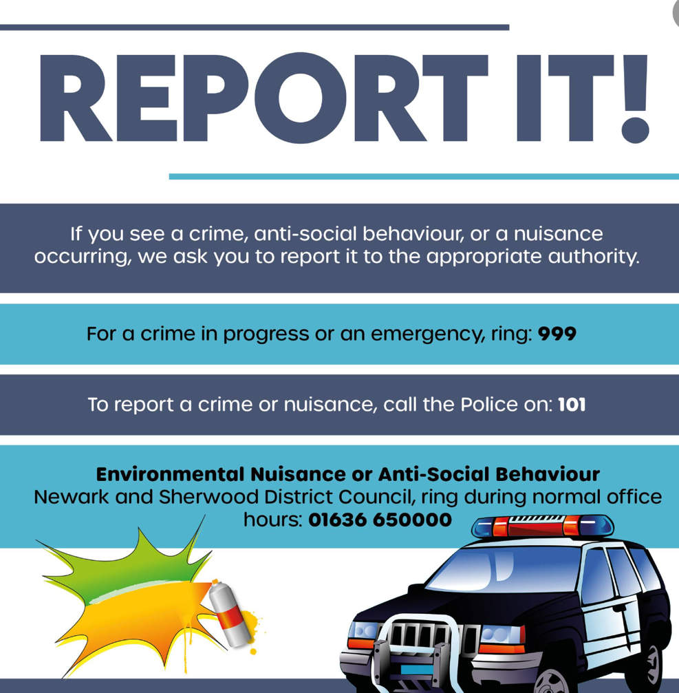

Newark & Sherwood District Council have asked the public to report anti-social behaviour and have issued this guidance
Anti-social behaviour (ASB) is behaviour which causes nuisance, harassment, alarm or distress to one or more people in different households. It can affect anyone at any time and is often deeply threatening to our sense of safety.
Please help by reporting anti-social behaviour whenever you see it to keep our communities safe. You can speak to the ASB team at Newark & Sherwood District Council, in confidence, about any issues or concerns you may have. To register an ASB complaint, you can contact us or use the online ASB reporting form on the website:
https://www.newark-sherwooddc.gov.uk/asb
If you wish to speak to a member of the Anti-Social Behaviour team confidentially then please call 01636 650000

Nottinghamshire Police
Our Police Community Support Officers
PC 3430 Nicola Best
Beat Manager for Edwinstowe & Clipstone
Ollerton Police Station, Forest Road, Ollerton NG22 9QZ
Telephone: 101 ext. 3103430 or Mobile: 07976 911901
Dave Keightley
David.Keightley@notts.police.uk
Mob: 07966 300571
If no one picks up the advice is to ring 101 & if they don’t pick up then their advice is to report online.
https://www.nottinghamshire.police.uk/ro/report/asb/asb-v3/report-antisocial-behaviour/

Reporting Other Issues

Newark & Sherwood District Council
All issues below can be reported via an online reporting form or through the customer services and general enquiries email and telephone number:

Website: https://www.newark-sherwooddc.gov.uk/report
Customer services and general enquiries: customerservices@newark-sherwooddc.gov.uk
Telephone: 01636 650000

- Abandoned Vehicles not causing an obstruction
N.B. If a vehicle is obstructing the road it should be reported to the Police. If it is obstructing the pavement, it should be reported to Nottinghamshire County Council Highways Team
- Report someone breaking planning rules
- Damaged residential bin
- Missed household bins / damaged bins
- Damaged street nameplate
- Dead animal
- Dog bins
- Flytipping
- Graffiti or flyposting
- Litter
- Street cleaning, including dog fouling
- Litter bins
- Lost dog
- Noise problems

Nottinghamshire County Council
Issues concerning roads should be reported to Nottinghamshire County Council
- Potholes. There is a specific form for potholes which covers the reporting of road damage, road pothole, pavement damage e.g. damage to a dropped kerb or pavement pothole
https://www.nottinghamshire.gov.uk/transport/roads/potholes/report-a-pothole

- Report a road or pavement problem
https://www.nottinghamshire.gov.uk/transport/roads/report-a-road-or-pavement-problem
- road marking renewal
- cycle track damage
- cycle track lining issues
- cycling issues caused by roadworks
- any other cycling issues
- a problem with a newly laid road
- a problem with a public footpath or bridleway
- travellers camping on the highway
- a roadwork problem
- parking-related problems.

Issues can be reported through the Nottinghamshire County Council Customer Service Team on 0300 500 8080. Lines open: Monday -Thursday 8.30 – 5.00, Friday 8.30 – 4.30

Also on your phone through the MyNotts App
