SUTTON VALENCE PARISH COUNCIL

From the Clerk:
Mrs Janet Burnett E-mail: clerk@suttonvalence.org.uk The Parish Office Sutton Valence Village Hall Sutton Valence
Tel: 01622 844135 Maidstone
Web site: www.suttonvalencepc.kentparishes.gov.uk Kent ME17 3HS

Notice is hereby given of an extra ordinary meeting of the Parish Council to be held on Thursday September 30 2021, at 7.00pm at the Committee room, Sutton Valence Village Hall when the following business is proposed to be transacted:
The Chairman to ask if anyone is recording
- Apologies for absence
- Declaration of lobbying
- Declaration of Changes to the Register of Interests
- Declaration of Interest in items on the agenda
- Requests for Dispensation
- Deputy Clerk
Interview questions to be approved
- Planning
- Planning recommendation ratification to be made on:
- 21/504690/FULL Henikers, Heniker Lane, ME17 3EE
Section 73 - application for removal of condition 4 (private use of stabling, schooling and land) pursuant to MA/14/0282 for - Change of use of land to equestrian and construction of a new timber stable block, stable yard/parking area and manege and retrospective application for replacement access gates.
- Planning recommendation to be made on the following
    - 21/504823/LBC Osbourne House, North Street, ME17 3HU
Listed Building Consent for installation of 2no. 8 panel solar PV systems to either side of roof ridge.
    - 21/504821/FULL Henikers, Heniker Lane, ME17 3EE
Part conversion of existing garage and store into an annexe ancillary to the main dwelling house (Retrospective).
    - 21/505080/FULL East Went Chartway Street ME17 3JA
Erection of 1no. new detached 5no. bedroom house with associated parking and rear garden, bin and bike store, and new woodland planting to the rear.
5. Pavilion – request by groundsman to repair floor and showers.

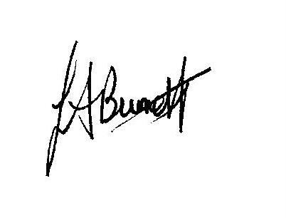

Janet Burnett – Clerk to the Council 24/9/21

