To all Great Milton Parish Councillors:

You are summonsed to attend a PARISH COUNCIL MEETING on Monday 16th April 2012 at the earlier time of 7pm in the Pavilion:

38/12 Apologies for Absence
To receive apologies for absence from the meeting.

39/12 Register of Interests for this Meeting
To receive declarations of interest in matters on the Agenda.

40/12 Minutes of the Previous Meeting
To approve and sign minutes of the PC meeting held Monday 19th March 2012.

41/12 Matters to Report
To receive updates from the neighbourhood policing team, District and County Cllrs, the Clerk and receive progress reports (not appearing as agenda items), including:

A Matters for Highways
B Progress with Parish Council Action List
C Facilities for Young People in Great Milton

42/12 Correspondence and Public Discussion
To take questions from the public and receive items of correspondence.

43/12 Planning Applications
A To consider the following planning applications:
Great Milton C of E School, Great Milton, OX44 7NT. P11/S0196. Retention and continued use of two modular building units (ref T1 CE01 Children’s Centre base office and T2 a classroom) for a further period of five years.

Amendment to Farriers Cottage, Church Road, Great Milton, OX44 7PB. P11/W2334. Two storey extension to rear of property to provide ground floor cloakroom off family room and ensuite bathroom at 1st floor level. Single storey extension to side of property to provide utility room and playroom.

Orpwoods Farm, Thame Road, Great Milton, OX44 7JD. P11/W2426/LDE. Application for Lawful Development Certificate for an existing use.

B To review any planning decisions received and any outstanding planning matters.

44/12 Diamond Jubilee Celebrations
To consider making a donation of Jubilee products / memorabilia and to agree any expenditure.

45/12 Housing Needs Survey
To consider Oxfordshire Rural Communities Council offer of support to complete a Housing Needs Survey in response to the needs expressed in the Parish Plan and agree any action.

46/12 Financial Resolutions
A To review and approve a quarterly bank reconciliation with analysis of actual receipts and payments versus budget.

B To approve an increase of one salary point to the Clerk’s pay in accordance with her employment contract, to NJC salary point LC1.18 (8.919 pence per hour) and to increase the number of hours worked by one hour from 8.5 hours to 9.5 per week to allow for the additional work involved in managing advertising for The Bulletin.

C To authorise the following cheques for payment and to sign the related invoices:

Joanna Botha. April salary. £367.20 (TBC)
Jonathan Dudley. Bulletin Production. TBC
Recreation Ground Management Committee. Insurance. £896.15
E.V. Hawes. Supply and fit new ball valve to allotment water tank. £84.00
Thames Water Utilities. Allotment supply. £2.73

47/12 Any Other Business
This part of the meeting may be used to bring the Clerk’s attention to village maintenance issues, inform the meeting of any notices or diary dates and to propose future agenda items.

All members of the press and public are very welcome at this meeting. The next Great Milton Parish Council meeting will be the Annual Meeting of the Parish Council on Monday May 21st 2012 at 7.30pm in the Pavilion.

Signed: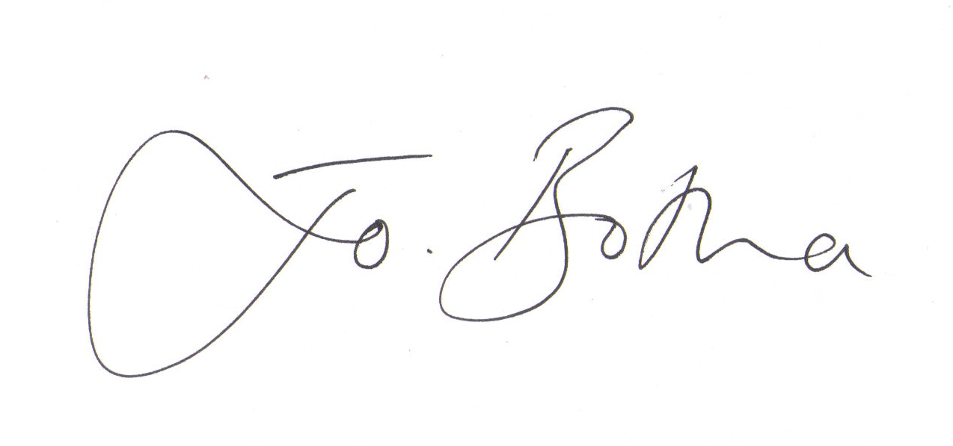

Joanna Botha
Clerk/Responsible Financial Officer

