

Halam WI
August Newsletter
Hello everyone,
Plans for the next few months:
On Monday we had a socially distanced committee meeting in my garden so that we could make plans for the next couple of months. I have spoken to the Parish Council who tell me that the village hall will not be reopened at the moment. With this is mind and as the situation is changing daily, we decided that it would be best not to hold WI meetings in September, October or November but will hopefully be able to organise a get together for Christmas. Obviously if the situation changes, this will be reviewed and an indoor meeting organised.

In the meantime, we have arranged an outdoor social gathering where we can have a socially distanced catch up over a cup of tea. This will be on Tuesday 18th August 7.30pm at the Milkshed, Halam. As we can’t provide refreshments, we are asking that you either bring your own or the Milkshed does have a coffee machine which will be open for you to purchase a coffee or a hot chocolate (£2) and they also have small pots of ice cream or a selection of wrapped biscuits. There are some picnic benches there, but you could bring your own deckchair if you prefer. Please give me a call if you require a lift there. (Please remember there are no toilets there)
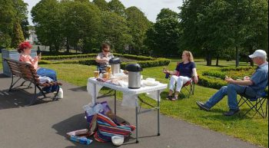

As we’re not going to be meeting regularly over the next few months, I am going to carry on producing newsletters, but I’d like your help with the content. Maybe you could send me a favourite recipe, a gardening tip, a book review, craft activity or a ‘do you remember when …’ memory from a WI trip or activity which I could include.

Information
NHS Test and Trace scam alert - fraudsters are attempting to exploit the system through bogus phone calls, emails and text messages which ask for bank card details to cover the cost of the testing kit. The genuine NHS service is free
Facemasks
Debbie Kenyon has made and distributed over 150 washable face masks. A bit of a Farnsfield sweet shop going on. If anyone wants one, she is charging £1 to cover costs of materials.
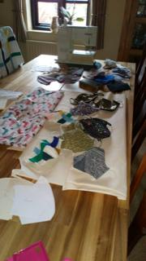

Who is this handsome chap?
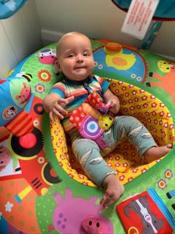

Teddy Bowling is coming up 6 months old now. Katie says he’s starting to learn to sit up, really enjoys bath time and trips out.


Finally, am I sure you will join me in wishing Olive Sharman a Happy 80th Birthday.

I hope to see you on Tuesday 18th August.
Stay safe and keep well.
Sara

