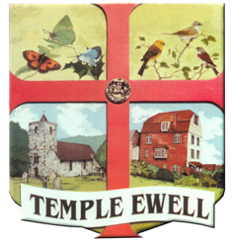
TEMPLE EWELL PARISH COUNCIL
Clerk: Andy Howard-Grigg Tel: 01304 361774
Merleigh, Northbourne Road, Great Mongeham, Deal, Kent CT14 0HJ Email: TempleEwellPC@Outlook.Com Website: templeewellpc.world
Facebook: Temple Ewell Parish Council. Twitter:@ewellpc

Register of Land held by Registered Charities of which the Parish Council is a Trustee

King George V Playing Field, Brookside, Temple Ewell, Dover (2.19 acres)
Gifted by Madeline Watson 15/3/1938 and subject to a Deed of Dedication as a King George V Playing Field dated 27/3/1950. Registered Charity No. 302856.

Allotment Gardens behind properties on the North side of London Road, Temple Ewell (3.73 acres)
Gifted under the Will of the late Madeline Watson 9/2/1949 to Temple Ewell Parish Council. Registered Charity No. 261472.

Other Land owned by Temple Ewell Parish Council

Small Car Park on the North-East side of London Road, Temple Ewell between George & Dragon Place and Templeside (0.06 acres). Gifted by Madeline Watson to the Corporation of Dover 2/10/1934 then transferred to Temple Ewell Parish Council 27/9/1985.

Small parcel of land forming steps adjoining Kestrel Cottage, London Road, Temple Ewell leading to Dragon Wood Car Park transferred to Temple Ewell Parish Council from MF Estates Limited 3/5/2006. (0.01 acres)

Land forming Dragon Wood and the associated Car Park on the North side of London Road, Temple Ewell, subject to a Deed of Dedication to Fields in Trust dated 6/11/2013.

Land on the West side of Church Hill (forming a Car Park) registered to Temple Ewell Parish Council 20/3/1990. (0.05 acres)

