Marsh Gibbon Neighbourhood Development Plan Evidence Base Report
Approved by MGPC 10/06/2014

Contents | Page
Introduction | 3
Population Trends | 4
Household Trends | 6
Employment | 9
Traffic & Transport | 12
Built Environment | 15
Green Spaces | 19
Natural Environment | 20
Appendices  1. Projecting Housing Requirements (G L Hearn)  2. Housing Survey (Community Impact Bucks) | 21  23
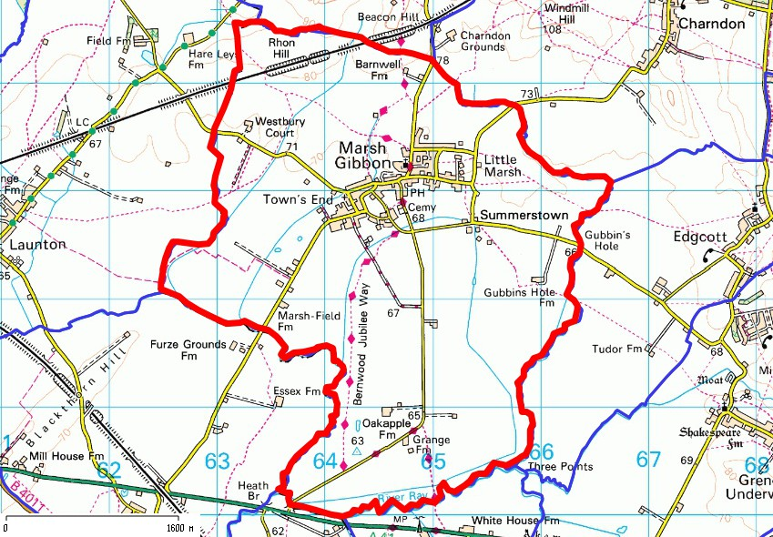
This is the Marsh Gibbon Neighbourhood Area approved by AVDC.
The Evidence Base Report
Introduction

- Marsh Gibbon Parish Council prepared a Village Plan in 2011 that sets out actions the residents wish to see implemented to maintain the village as a very pleasant, diverse and safe place to live. A survey of the village to obtain residents’ views about the way forward on a wide variety of matters was carried out in 2010 and the results of this underpinned the proposals in the Village Plan. One of the requests arising from the survey was that the Parish Council should prepare a land use plan to help steer future change. The Neighbourhood Development Plan is the vehicle for this initiative.

- The evidence base for this plan relies in part on the survey undertaken in 2010 and also on the results of the 2011 census, consultation with our residents about the draft Plan policies and proposals and discussions with our local planning authority

Marsh Gibbon in the sub-region.

- Like many rural areas Marsh Gibbon has changed considerably over the last 100 years and particularly since the last war. It used to be a self-contained agricultural community. Now it is a much more mixed population with very few people employed in agriculture (3%) and the majority seeking work outside the village. The development of the railways and more recently the M40 have facilitated easy access to other work centres. We are 15 minutes from the M40, we are close to the London commuter stations at Bicester and Aylesbury and the pressure for more market led growth in Marsh Gibbon will be considerable in the coming years.

- Aylesbury Vale District Council’s strategic plan, Aylesbury Vale District Local Plan (AVDLP), recognises this pressure and seeks to steer economic and housing growth to the major towns (Aylesbury, Buckingham and Winslow) and to reduce journeys to work and ease pressures on the rural environment. In recognition of these factors it has set out policies in the AVDLP for the rural area in which Marsh Gibbon sits that are designed to accommodate limited growth, largely for local needs and seek to strike a balance between local homes and local jobs, recognising that diversification in agriculture needs to be accommodated.
- New development plans must be set in the context of the government’s National Planning Policy Framework (NPPF) that has as its starting point that plans should build in a presumption in favour of sustainable development. The NPPF encourages local communities to produce their own Neighbourhood Development Plans set in the context of current District Local Plans and to work in cooperation with District Councils. We have followed this guidance and our plan conforms with the NPPF.
Population trends

- Table 1 below (population age structure 2001-2011) shows the changes that have taken place in the village between the last two censuses and compares the village with the age structure in the Vale as a whole in 2011.
Table 1 Marsh Gibbon: Population age structure 2001-2011
 |  | 2001 |  |  |  | 2011 |  | 2011
 |  | Marsh Gibbon |  | Marsh Gibbon |  |  | Aylesbury Vale
All people |  | 990 |  | 969 |  |  |  | 174,137
0-4yrs | no | 48 |  | 65
 | % | 4.8 |  | 6.7 |  |  |  | 6.5
5-7yrs | no. | 37 |  | 31
 | % | 3.7 |  | 3.2 |  |  |  | 3.7
8-14yrs | no. | 107 |  | 81
 | % | 10.8 |  | 8.4 |  |  |  | 8.8
15-19 | no. | 58 |  | 50
 | % | 5.8 |  | 5.2 |  |  |  | 6.2
20-29yrs | no. | 88 |  | 73
 | % | 8.8 |  | 7.5 |  |  |  | 10.7
30-44yrs | no. | 234 |  | 206
 | % | 23.6 |  | 21.3 |  |  |  | 21.3
45-59 | no. | 248 |  | 235
 | % | 25 |  | 24.3 |  |  |  | 21.5
60-74yrs | no. | 111 |  | 164
 | % | 11.2 |  | 16.9 |  |  |  | 14.4
75-84yrs | no. | 45 |  | 51
 | % | 4.5 |  | 5.3 |  |  |  | 4.9
85-95yrs | no. | 14 |  | 13
 | % | 1.4 |  | 1.3 |  |  |  | 1.9
Source: Census tables

- The village population in 2001 was 990 and fell to 969 in 2011, a decrease of 2%. This compares with an increase of 5% in the Vale as a whole. The fall may be partly the result of an ageing population and lack of new homes for local people with young children to live in.

- The 60- 74 year age group has increased significantly since 2001; 16.9% of the population compared with 11.2% in 2001. The older age groups are significantly larger than those in the Vale. Over the next twenty years 235 residents in the 45-59 age group will move into the over 60 group and the over 75 sector will swell even further.

- It is interesting to note the increase in births over the last ten years in Marsh which might herald the beginning of a more youthful age profile over the long term. On the other hand this trend might be the result of births from a generation that has left family creation until their late thirties and one that is not repeated.

- The size of the population growth over the plan period will very much depend on the number and type of homes that are built and this is covered in another section (see paras 18-20). What is likely is that the 60-74 age group could increase from 16.9% to 23% if national forecasts are realised in the village.

Household Trends

- Table 2 below shows the household spaces and accommodation types in Marsh Gibbon for the two census years and also compares 2011 with Aylesbury Vale.

Table 2 Marsh Gibbon: Household spaces and accommodation type.
 |  |  | 2001  Marsh Gibbon |  | 2011  Marsh Gibbon |  | 2011  Aylesbury Vale
All dwellings |  |  | 402 |  | 409 |  | 71883
Dwellings : 1+ usual resident |  | no.  % | 396  98.5 |  | 390  95.4 |  | 96.3
Dwellings : no usual resident |  | no.  % | 6  1.5 |  | 19  4.6 |  | 3.7
Detached house/ bungalow |  | no.  % | 205  51 |  | 214  52.3 |  | 32.3
Semi-detached house/bungalow |  | no.  % | 125  31.1 |  | 126  30.8 |  | 32.0
Terraced house/bungalow |  | no.  % | 46  11.4 |  | 45  11 |  | 23.5
Flat, maisonette, or apartment |  | no.  % | 26  6.5 |  | 24  5.8 |  | 12.0
Source: Census tables

- The number of homes increased by 1.5% between 2001 and 2011 compared with an increase in the Vale of 11%. The greater affluence of Marsh Gibbon is illustrated by the high % of detached dwellings compared with the Vale (52% compared to 32%) and that most of the additional dwellings recorded between the censuses were of this type. The number of homes with no usual resident increased from 6 to 19 comprising 4.6% of the housing stock. This probably contributes to the overall small decline in the population numbers.

- The District Council’s own records show there were 418 dwellings in the village in 2010 and that no housing completions took place from 2005 to 2007 and then 6 in 2008 and 2 in 2009 and 2010. No affordable homes or rural exception scheme homes were built in the period. However there were 16 housing commitments, including the Station Road rural exception site (8 homes in Piece Close) which have now been completed and either sold or rented. A survey of local housing need was carried out in 2006 that identified the need for local social housing and the Piece Close scheme was commissioned to meet that need. The difference between dwellings counted in the 2011 census (409) and AVDC’s figures (418 in 2010) may be accounted for by the census using data from the Valuation Offices that may lag behind actual completions.

- Table 3 shows the census records of housing tenure in the village, the changes that have taken place and compares the figures with Aylesbury Vale.
Table 3 Marsh Gibbon : Housing tenure 2001-2011
 |  |  |  | 2001 | 2011 | 2011
 |  |  |  | Marsh Gibbon | Marsh Gibbon | Aylesbury Vale
All Households |  |  |  | 392 | 390 | 69406
Owned |  |  | no. | 279 | 275
 |  |  | % | 71.2 | 70.6 | 71.6
Shared ownership |  |  | no. | 0 | 1
 |  |  | % | 0 | 0.2 | 0.9
Social rented |  |  | no. | 34 | 15
 |  |  | % | 8.7 | 3.8 | 3.4
Social rented : other/housing |  |  | no. | 29 | 41
association |  |  | % | 7.4 | 10.5 | 9.6
Private rented |  |  | no. | 50 | 49
 |  |  | % | 12.7 | 12.5 | 13.3
Living rent free |  |  | no. | n/a | 9
 |  |  | % | n/a | 2.3 | 1.3
Source: Census

- Home ownership has not changed much over the last ten years and surprisingly the % of rented homes (26.8%) matches the figure for the Vale as a whole. This is in part due to the large stock of Ewelme Trust houses that were originally built for local farm workers and later rented to local people. More recently the homes are being rented at full market price and a number of non-local people have taken tenancies. There is therefore a prospect that the homes could slip from meeting local need to accommodating all comers. This is unfortunate but the Trust Deed does not allow the Trust to restrict the market for their homes or to let them at subsidised rents. Such a housing stock could help meet the longer term need for affordable social housing if a solution could be found to this embargo. The village supports such an initiative if it is possible.

- Table 4 below shows the distribution of homes by tax band compared with those in Aylesbury Vale.

Table 4 : Dwellings by Council Tax band 2011
 |  | 2011 |  | 2011
 |  | Marsh Gibbon |  | Aylesbury Vale
Band A | % | 4.8 |  | 4.3
Band B | % | 8.3 |  | 16.4
Band C | % | 24.6 |  | 28.9
Band D | % | 10.9 |  | 17.1
Band E | % | 23.2 |  | 14.4
Band F | % | 10 |  | 10.3
Band G | % | 17.8 |  | 8
Band H | % | 0.2 |  | 0

- The differences are most marked at the lower and upper ends of the tax bands and reflect the greater prosperity of many residents in Marsh Gibbon compared with Aylesbury Vales as a whole. In Marsh Gibbon bands A and B comprise 13.1% of the households compared with 20.7% in the Vale whereas bands E-G in Marsh comprise 50.9% of the households compared with 32.7% in the Vale. The Band E-G residents who work are most likely to commute, often to London, and have created a demand for larger desirable homes.

- At the beginning of our work on the Neighbourhood Plan we asked consultants (GL Hearn) to produce estimates of housing need up to 2031 arising from the local population growth. Hearns had produced projections for the District Council Strategic Plan and they used a similar range of models. The base line for the projections was the Marsh Gibbon ward information from 2001 and adjusted to 2006. This suggested that Marsh had a younger population than the rest of the district. Various projections were made and a zero net migration projection indicated that 5 new homes per year would meet local need.

- The residents have been asked their view about housing growth and there was general support for an average of 4 homes per year over the plan period. Since these views were sought the 2011 census results have become available and they indicate Marsh Gibbon now has an older population than that of the Vale (see above). Hearns have therefore re-run their projections using 2011 parish and ward figures and have concluded that we would be advised to make provision for housing growth suggested by trend based and zero employment growth based projections. These projections both indicate an average of 3 dwellings per year up to 2031 (see appendix 1).

- The Parish Council was concerned to try and secure a better understanding of the type of local housing need that might arise in the short term and therefore commissioned Community Impact Bucks to carry out a survey of local residents in January 2014 and this organisation reported in February 2014 (for the full report see the Parish Council website). The survey secured a 26% response and the general conclusions were that residents equally supported

- Homes for elderly downsizers, for sale on the open market
- 2 and 3 bedroom homes for sale on the open market and
- Affordable homes for local people

Over the next 4+ years 38 residents saw themselves moving within the village with 31 wanting to buy on the open market, 4 wanting to purchase through shared ownership and 3 seeking rented accommodation. Half of the respondents (19) were looking for a house, 35% (13) a bungalow and 8% (3) sheltered accommodation. It is interesting to note that the 19-29 age group responded less well to the survey and this might imply an under estimate of the need for rented or shared ownership properties. The future need for bungalows and sheltered accommodation very much reflects the age structure of the village at present and in the future.
Employment

- On the whole Marsh Gibbon is a prosperous community. It enjoys high levels of employment, high average incomes, above average levels of education and achievement and we are considerably healthier than the national average.

- Table 5 shows that 79.5% of the 16-74 population age group in 2011 was economically active compared with 69.9% in England. Many are self-employed (15.9% compared with 9.8% in England) and a significant proportion work from home (7.4% compared with 3.5% in England)

Table 5: People in employment in Marsh Gibbon 2011
Economically active residents | Economically inactive residents | Full-time employees | Part-time employees
571 | 147 | 332 | 96
79.5% of people aged 16-74 (England average = 69.9%) | 20.5% of people aged 16-74 (England average = 30.1%) | 46.2% of people aged 16-74 (England average = 38.6%) | 13.4% of people aged 16-74 (England average = 13.7%)
Self-employed | Working 49+ hours per week | Working from home | Employed in the public sector
114 | 121 | 55 | 150
15.9% of people aged 16-74 (England average = 9.8%) | 21.7% of people in employment (England average = 13.3%) | 7.4% of people aged 16-74 (England = 3.5%) | 26.9% of 550 people in employment (England = 28.2%)

- The workforce is well qualified outstripping that of the rest of Buckinghamshire and England. (see table 6 below)

Table 6: Skill levels in Marsh Gibbon 2011

People with no qualifications | People with highest qualification: Level 1 | People with highest qualification: Level 2 | People with highest qualification: Level 3
115 | 85 | 120 | 95
14.8% of people aged 16+ (England= 22.5%) | 10.7% of people aged 16+ (England= 13.3%) | 15.5% of people aged 16+ (England= 15.2%) | 12.1% of people aged 16+ (England= 12.4%)  Rest of table see over
People with highest qualification: Level 4 (degree level qualifications)
305
39.1% of people aged 16+ (England= 27.4%)
‘Level 1’ qualifications are equivalent to a single O-level, GCSE or NVQ. ‘Level 2’ qualifications are equivalent to five O-levels or GCSEs. ‘Level 3’ qualifications are equivalent to two A levels. ‘Level 4’ qualifications are equivalent to degree level or higher.

- The workforce characteristics very much reflect the type and size of homes we have in Marsh Gibbon (see previous housing section) and the fact that we are now very much a commuter settlement for Bicester, Oxford, Aylesbury and London. Table 7 below sets out the type of jobs the residents have. The largest employment groups are retail, professional occupations and health and social work.

Table 7: Main job types 2011

Largest employment sector |  | Second largest employment sector | Third largest employment sector
Retail |  | Professional | Health and social work
95 employees (17% of 550 of people in employment) |  | 65 employees (12% of 550 of people in employment) | 60 employees (11% of 550 of people in employment)
Managerial occupations | Professional or associate occupations | Administrative or secretarial occupations | Skilled trades occupations | Elementary occupations
85 | 215 | 55 | 65 | 20
15.4% of 550 people in employment (England = 15.3%) | 38.7% of 550 people in employment (England = 30.3%) | 10.2% of 550 people in employment (England = 11.5%) | 11.6% of 550 people in employment (England = 11.4%) | 3.9% of 550 people in employment (England = 11.1%)

- Local employment in the village includes five active farms and several smaller farms where the land is let out on contract, a small brewery, the school, the shop, pubs and the garage, two outlets for building supplies and machinery, and of course the 50+ people who choose to work from home following a diversity of employments. The majority of the village residents are employed outside the village and when we consulted them in 2010 about the future of the village there was strong support for a plan that would safeguard local jobs and, more particularly encourage growth of further jobs for local people. Policy MG9 is designed to help meet this aim and also help reduce out commuting trips.

- Local businesses can attract heavy vehicle traffic and this has been a problem in parts of the village where the roads are narrow and mainly serve established residential streets. Policy MG10 is designed to accommodate proposals to relocate such employment uses to more suitable locations. Policy MG9 also deals with problems of heavy traffic that might arise from new employment developments.

- Whilst Marsh Gibbon was once primarily an agricultural community with homes built especially for Ewelme farm workers there has been a dramatic change over the last century. In 1841 in England and Wales 22% of the work force were employed in agriculture and fisheries but by 2011 this had fallen to 0.8% in England, 1.3% in Aylesbury Vale and 3.0% in Marsh Gibbon. The demand for greater productivity and increased mechanisation has brought this about. In 1900 one agricultural worker fed around 25 people, in 2010 one worker fed 200 people – an 800% increase in productivity.

- It is very likely that that this trend will continue and could well affect the farms in Marsh Gibbon. This might lead to an amalgamation of farms, the need for new, more modern buildings and plant and a search for sites away from the village where such operations can be carried more efficiently. Agriculture and its environment is very important to the village and we wish to see it prosper in an increasingly challenging market. Policy MG12 is designed to facilitate change in the local agricultural economy whilst safeguarding the small scale residential environment and help to move heavy traffic out of the village. Such a policy might also provide an opportunity for small scale employment uses to be developed in redundant farm buildings or to use redundant sites for local need homes.

Traffic and Transport

- Bucks County Council has produced a local transport plan with local area strategies. In our area (Haddenham, Long Crendon and Waddesdon) the public listed their concerns as :
- Poor quality of roads and pavements
- Inadequate rural transport provision
- Congestion on the A41
- Heavy freight traffic travelling to badly located businesses
- And “rat running” of through traffic
These concerns were echoed by the Marsh Gibbon residents when they were consulted about the Village Plan. The County Council strategy seeks to address these problems but the solutions and timing are unclear at the moment.

- Car and van ownership and availability has increased significantly and the figures are set out below in table 5. In Marsh Gibbon ownership and availability of vehicles has increased between 2001 and 2011 by 11% and households with two cars or more is 260 or66%. This compares with 48.5% in the Vale as a whole. Households with three or more vehicles comprises 19.4% of all households

Table 8 Marsh Gibbon: car or van availability 2001 -2011

 |  |  | 2001 |  | 2011 |  | 2011
 |  |  | Marsh Gibbon |  | Marsh Gibbon |  | Aylesbury Vale
All households |  |  | 396 |  | 390 |  | 69,406
No cars or vans in hh |  | no. | 31 |  | 16
 |  | % | 7.8 |  | 4 |  | 13.3
1 car or van in hh |  | no. | 149 |  | 114
 |  | % | 37.6 |  | 29.2 |  | 38.1
2 cars or vans in hh |  | no. | 149 |  | 184
 |  | % | 37.6 |  | 47.2 |  | 36.2
3 cars or vans in hh |  | no. | 49 |  | 47
 |  | % | 12.3 |  | 12 |  | 8.8
4 /4+ cars or vans in hh |  | no. | 18 |  | 29
 |  | % | 4.5 |  | 7.4 |  | 3.5
Total vehicles available |  |  | 666 |  | 739
% increase 2001- 2011 |  |  |  |  | 11%
Source : Census tables

- This significant increase in car ownership is amply illustrated by the number of cars parked on the roads and pavements, damaging the environment and creating a hazard for pedestrians. Over the plan period it is obvious that this problem will get worse. It is clear that existing off road parking provision is inadequate and the present car parking standards applied to new development in the village exacerbate the problem. The neighbourhood plan proposes increased standards to help deal with this situation. (See policies MG15 & MG16).

- Car parking outside and near the primary school is a particular problem at arrival and going home times. Since the school attracts from a wide catchment many children arrive by car and the parked cars effectively create a one way system along Castle Street for about 200 metres as well as inconsiderate parking at nearby junctions and in residential streets. This is potentially dangerous and if proposals to expand the school go ahead the Parish Council will press for effective off road car parking to be provided. (see policy MG18)

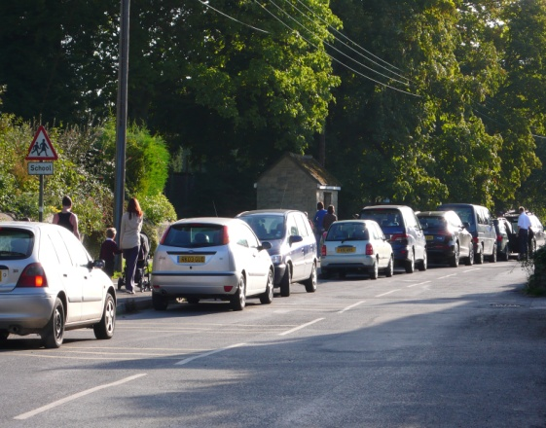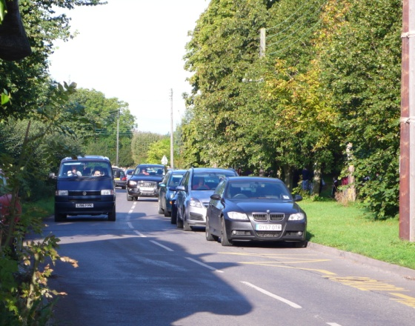
Parent parking outside the school

- Most of the village is served with a good and convenient footpath network and the Parish Council wishes to see this protected. However between West Edge and Ware Pond there are no footpaths and this is a real danger, particularly for mothers and children en route to school. The Parish Council will seek to secure a new footpath away from the road to provide a safe pedestrian way. The route will be protected by the designation of a Local Green Space and this is discussed in the Green Spaces section below.
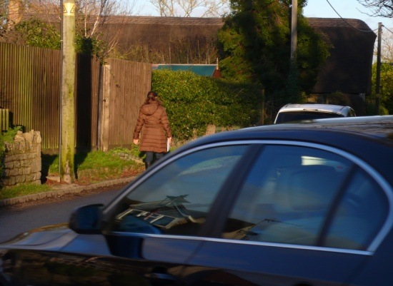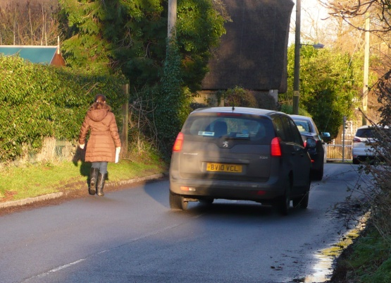  No footpath along West Edge

- Marsh Gibbon lies on a short cut route from the A41 to Calvert Green, Buckingham, Milton Keynes and the A43. In consequence commuters short cut through the village – often at high speed – and heavy lorries use the road en route to destinations in the north of the County and beyond. The Parish Council will work with the County Council to pursue initiatives to alleviate these problems.
The Built Environment
- The village has developed over many centuries and the buildings and streets reflect its long agricultural past, the availability of local stone and the unique ownership of much of the village in the hands of the Ewelme Trust. The village conservation area policy document, approved in 1980 succinctly describes the environmental qualities that are so valued by residents today: “The attraction of the village lies in its meandering street pattern, the rubble limestone, clay tile and thatched buildings, the long sweeps of linking stone boundary walls and wide grass verges. Of particular interest are the farm buildings which form an integral part of the street scene.”
- The village includes three separate conservation area designations that embrace historic groups of farms, houses, pubs and the church. (See plan at back of Report)
  - The western conservation area comprising the old parts of Townsend and West Edge, possesses a most attractive sense of enclosure with the Greyhound pub and larger 3 storey old homes providing an architectural focus. This part of the village is also a focus for the Greyhound Club established in 1788, the village silver band and the annual celebration of the club parade, feast and fair on oak apple day.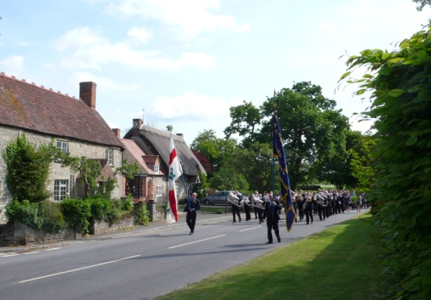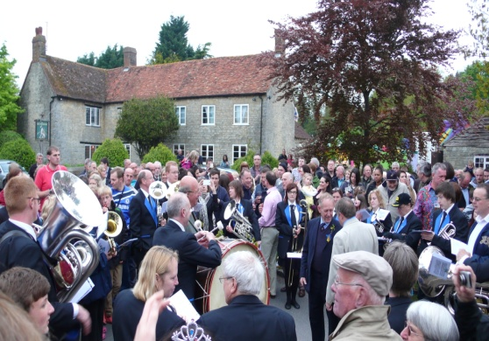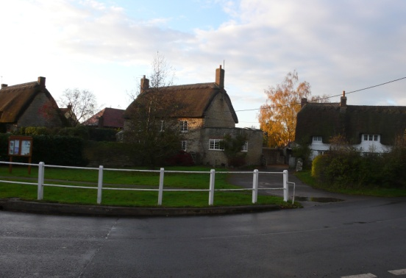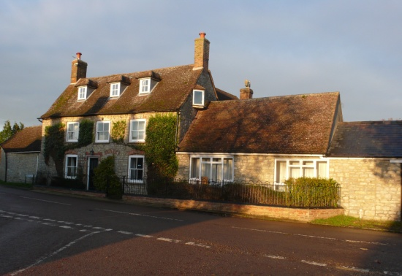
Around The Greyhound on Club Day
  - The central conservation area comprises two distinct enclosed old building groups. The first is grouped around the Ware Pond and the architectural focus is provided by Westbury Manor, The Old Village Stores and Ware Farmhouse which are in stone, slate roofs and three storeys in height. The second focuses on The Manor, St. Mary’s Church and The Plough Pub which provide dominant height to the group. These two parts of the conservation area are linked by Acland Terrace, eight stone cottages built in the 19th century for farm workers by the Ewelme Trust and represent a very good example of social housing which were well ahead of their time.
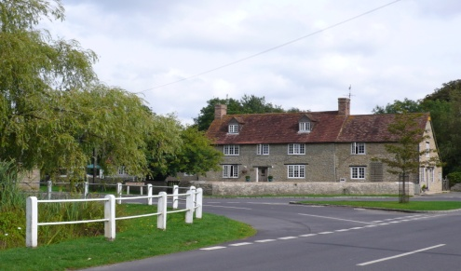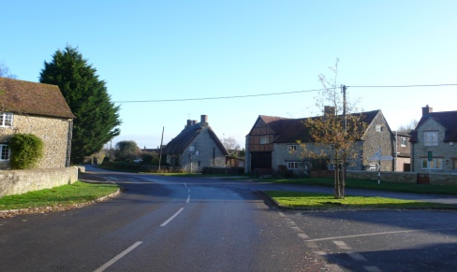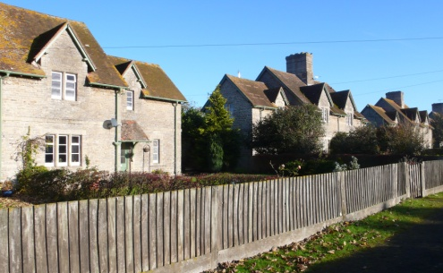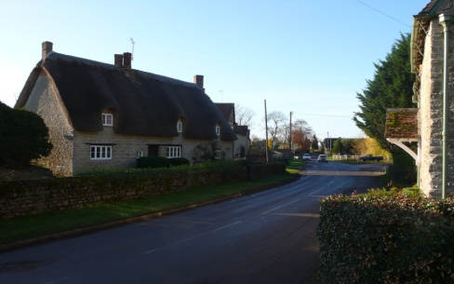
Central conservation area around and near Ware Pond
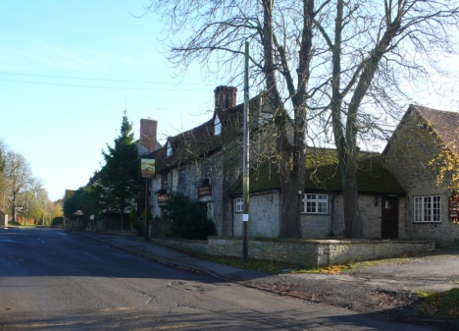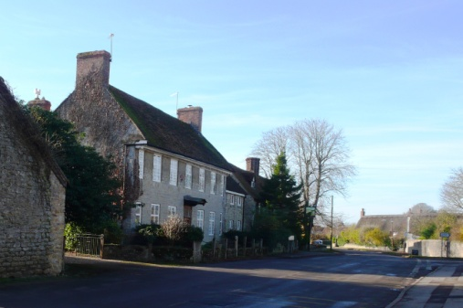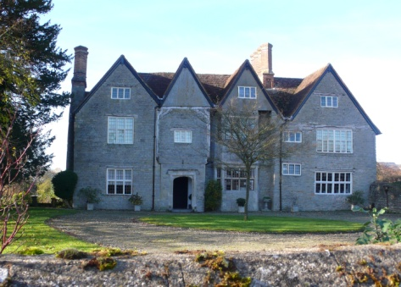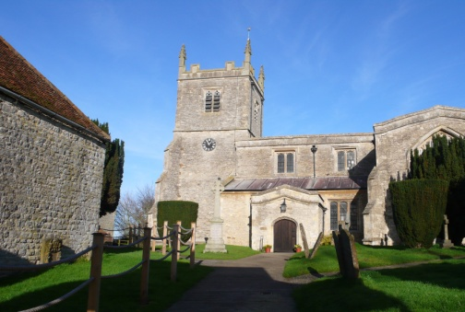
Central conservation area near The Plough, Manor and Church
  - The third conservation area on the eastern edge of the village is a contrast. The grouping is open with views in and out of the village and Swan field provides a rural backdrop to Swan Lane, Swan Farm, more Ewelme Trust cottages and the homes along Scotts Close. The conservation area document notes “the particular importance of the 10 acre paddock” – Swan Field - and the development control policy notes that “Special care will be exercised to conserve the easternmost part of the village”
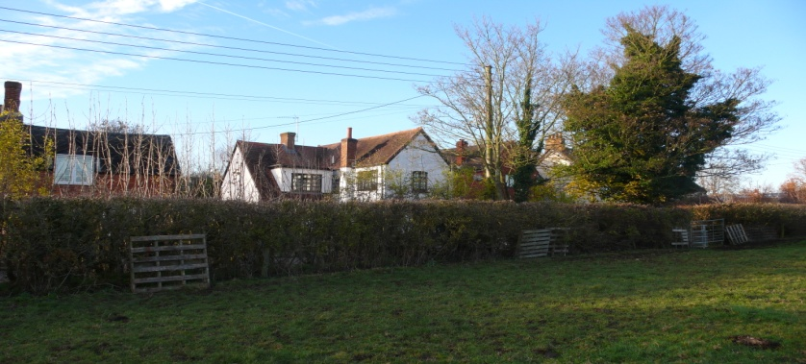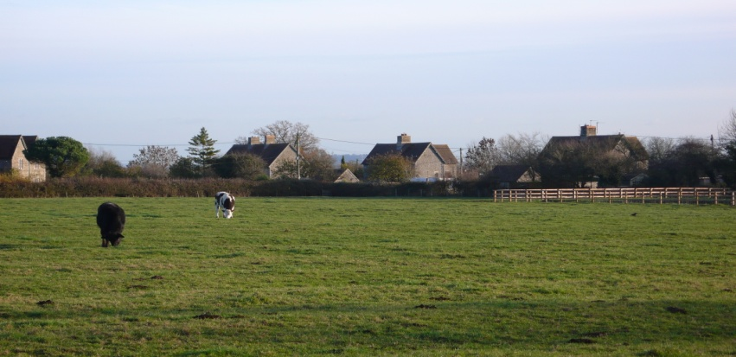
Swan Field from the footpath: adjacent to Swan Lane and the eastern conservation area.

- New development in or adjacent to the conservation areas has largely complemented the historic environment both with building materials and the scale of the architecture. When the village was consulted about the Village Plan respondents felt it was important to recognise and celebrate the rich history of the village and were keen to see these aspects preserved for future generations. It is these qualities and diversity of environments that the plan seeks to preserve and complement and policies MG1 & MG2, are directed to help secure this.
Heights of buildings in the village
- It is apparent from the description above that in the conservation areas the buildings heights are generally 2 storeys, whilst the community buildings and important farm houses and manors are three storeys. These provide the focus for the building groups and illustrate the past history of village life and development. In the newer areas almost all the development is no more than 2 storeys respecting the architectural dominance of important community buildings in the historic part of the village. These relationships are shown in the photographs above. Policies MG1 and MG2 are designed to help maintain this balance.
Building Materials
- Marsh Gibbon has been fortunate to have a local limestone supply and most of the historic homes and walls are built using this and the roofs are either thatched, slated or covered using hand-made clay tiles. (See photographs). These materials are particularly significant in the conservation areas and we wish to see this type of material used in or close to these areas. Outside the conservation areas bricks have also been used and new development should be in harmony with the surrounding environment and be of good quality.

Green spaces
- Marsh Gibbon is fortunate to possess a large recreation ground where football and cricket are played, a substantial children’s play area next to the village hall together with tennis courts. It also benefits from three allotment areas. The conservation areas provide attractive landscaped open urban spaces such as the green in front of the Greyhound pub and Ware Pond.
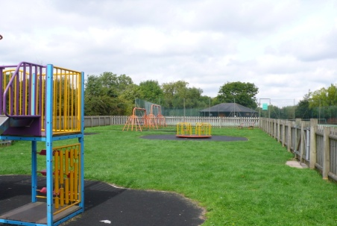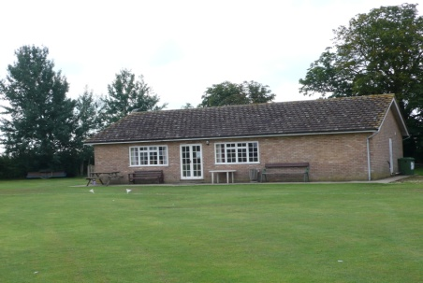
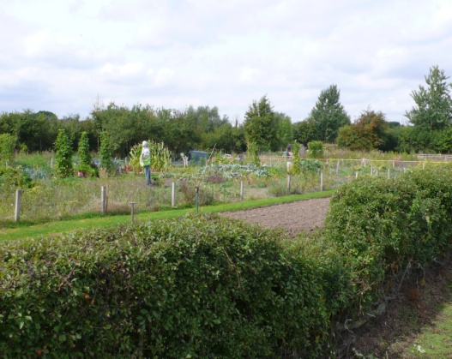
Recreation areas: playground, cricket football pitch and allotments
The Plan contains policies (MG19 & MG20) to protect and enhance these valuable facilities.
- Parts of the village also have the good fortune to be wrapped around two large fields (Swan Field and Moat Close) which provide a rural backdrop to the conservation areas. This environmental quality is particularly noted in the conservation area document. With regard to Swan Field the plan comments “Of particular importance is the 10 acre paddock lying between Swan Lane and the Trust Cottages in Swan Close” “Special Care will be exercised to conserve the open character of the easternmost part of the village.” Both Swan Field and Moat Close are identified in the plan analysis as areas that are important to keep open. Moat Close backs onto Westbury Manor and contains a medieval manorial site classified as an archaeological notification site that should be protected. It also provides an important backdrop to the Townsend/ West Edge conservation area.
- The government’s National Planning Policy Framework states that “Local
communities through local or neighbourhood plans should be able to identify for
special protection green areas of particular importance to them. By designating
land as Local Green Space local communities will be able to rule out new
development other than in very special circumstances.”
The guidance continues: “The designation should only be used:
- where the green space is in reasonably close proximity to the community it serves;
- where the green area is demonstrably special to a local community and
holds a particular local significance, for example because of its beauty,
historic significance, recreational value (including as a playing field),
tranquillity or richness of its wildlife; and
- where the green area concerned is local in character and is not an
extensive tract of land.”

- Marsh Gibbon residents regard Moat Close and Swan Field as special places in the local landscape and this view was endorsed in the conservation area analysis. The spaces are surrounded by village homes, they provide a backdrop to our conservation areas and contribute a unique environment to our village. We have concluded that they are appropriate to be classified as Local Green Spaces and are defined as such in policies MG3 and MG4.
The Natural Environment
- The environment of the built part of the parish is fortunate to contain many trees and hedgerows and residents wish to see this ambience remain and be enhanced. Many of the trees are mature and many are ash and the longer term prospects for tree cover must be uncertain. Many trees are protected by conservation area status or by tree preservation orders and the parish council believes that a survey of our tree stock needs to be carried out to establish the health of the trees and to see if further protection and planting may be necessary. Where new development is proposed there is a real opportunity to add to the tree stock and protect special trees and this view is reflected in policy MG21.

- The southern part of the parish includes the River Ray water meadows, a remnant of what was once a large part of the agricultural grazing land in this country. Some 90% of the water meadows have been lost nationwide in the last 50 years and there are now only about 2000 hectares left. The water meadows close to Marsh Gibbon are of national significance due to their quality and the quantity within a small local area. They contain a Site of Special Scientific Interest (SSSI), County Wildlife sites and nature reserves. The village wishes to see these areas preserved and we believe that national and local plan policies will secure their future.
Appendix 1
Projecting housing requirements in Marsh Gibbon: Report by G.L.Hearn April 2014
- Marsh Gibbon is a parish in the Rural North housing sub-market of Aylesbury Vale; there is also a ward of the same name comprising the Marsh Gibbon parish and a further five smaller parishes. The analysis in this document focuses on the parish although some data has been drawn from the wider ward where this is not available at a smaller area level (i.e. for parishes and particularly to inform detailed age/sex structure breakdowns).

- The population of Marsh Gibbon was 991 in 2001 and by 2011 this had fallen to 969 (data from the 2001 and 2011 Census). The number of households also fell in this period, from 400 to 390.

- In running projections we have accessed a range of sources, including the ONS 2011- and 2010-based subnational population projections (SNPP) and the 2011- and 2008-based household projections (by CLG). At a smaller area level the same assumptions around births and deaths as for Aylesbury Vale are used with migration patterns being adjusted to reflect likely differences due to the age structure in Marsh Gibbon. The age structure in the parish is shown below (this is taken from the 2011 Census and assumed to be the same as of mid-2011 – projections typically run for mid-year periods). This is compared with figures for the whole of Aylesbury Vale.
Figure 1 Baseline population (2011)
Source: ONS

- For Marsh Gibbon we have run a number of different projections based on published data and recent trends. The projections are:
- SNPP – based on the most recent sub-national population projections and assuming that Marsh Gibbon takes its share of the need arising across Aylesbury Vale
- Trend-based – based on looking at past population growth (District-wide) and projecting the same trend forward with Marsh Gibbon again taking its share
- Zero net-migration – studying the level of housing growth required if levels of in- and out-migration are in balance (at a parish level)
- Zero employment growth – the level of housing growth required to maintain a stable working age population (at a parish level)

- The figures (shown below) show a range of outputs from 89 dwellings required down to 34. We consider that the SNPP (at least for Aylesbury Vale) is too high and does not fit with past trends whilst we would consider that the zero net migration scenario would not represent positive planning (particularly as this would be expected to see a decline in the working-age population.

- Therefore we suggest that the main consideration should be given to trend-based and zero employment growth projections. Taken together these would suggests a need for around 60 additional homes to be provided (about 3 per annum).

Figure 2 Estimated housing requirements 2011-2031
 | Total (20-years) | Per annum
SNPP | 89 | 4
Trend based | 57 | 3
Zero net migration | 34 | 2
Zero employment growth | 66 | 3

- When projections were previously developed for the parish on the back of earlier work by GL Hearn the assessed numbers were generally higher. The key reason for the difference is that these projections now take account of the 2011-based CLG household projections (as well as the 2008-based version). The 2011-based projections tend to show more moderate levels of household formation than in the 2008-based data which was previously used. Other differences will be due to an updating of the age structure profile and a more detailed analysis of the likely migration patterns associated with the age structure.

Appendix 2

MARSH GIBBON PARISH
HOUSING NEEDS SURVEY
February 2014

Mrs Jean Fox
Rural Housing and Development
Community Impact Bucks
6 Centre Parade
Place Farm Way
Bucks
HP27 9JS

0845 3890389
Email: jean@communityimpactbucks.org.uk www.communityimpactbucks.org.uk

CONTENTS PAGE

- Introduction 2

- Issues in Rural Housing Today 3

- Survey Methodology 3

- Part 1 – Survey Response 4

- Part 2 – Housing Type Supported 6

- Part 3 – Housing Need 7

- Comments 14

- Additional Feedback 16

- Points to Consider 17

- Conclusion and Recommendations 19

APPENDIX I – Useful links and contacts

HOUSING SURVEY, MARSH GIBBON PARISH, FEBRUARY 2014

1. Introduction

This general housing survey has been commissioned by Marsh Gibbon Parish Council. The intention is to support and inform their Neighbourhood Development Plan process, to help establish a picture of housing needs in the parish and to act as a means for the community to detail their aspirations for housing within the parish.
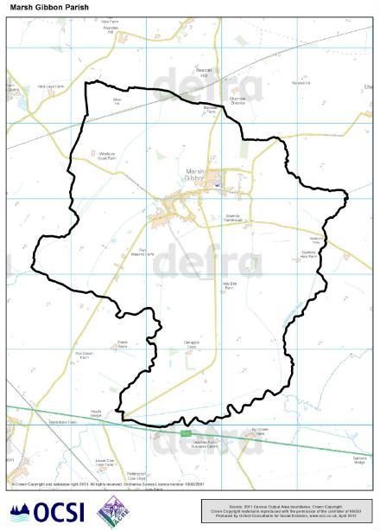

2. Issues in Rural Housing Today

There are a range of significant issues across the country today with regards to housing and these issues are no strangers to rural communities.
High house prices deter many first-time buyers from making that critical first step onto the housing ladder. At the same time those at the topmost part of the ladder, usually elderly, often find themselves in long-standing homes that are too big and/or unmanageable. There are many of those already established on the ladder who are seeing a deterioration in the viability and provision of local services such as good local schools and leisure facilities for themselves and their children.
For young people the incomes of those who work in the immediate areas, (for instance in agriculture, tourism and village services) tend to be lower than regional averages, making it difficult for them to live in the villages in which they work.
For the elderly in rural communities it is very likely that the availability of suitable properties to downsize into is limited, as is access to supported living, good health facilities and shops etc.
All of the above are further exacerbated, in rural areas, by a general paucity of good transport options for small communities, where the longer-term viability of services is often doubtful. Further, the efficiencies of support networks are more easily compromised due to the relative geographic remoteness of many rural communities e.g. availability of emergency/medical/home help services, especially during periods of severe winter weather.

3. Survey Methodology
The Parish Council commissioned Jean Fox from Community Impact Bucks to conduct a general housing survey in the community to help decide what type of homes were needed in the parish in the next 20 years.
The survey comprised of three parts:
Part 1 - asked for information about the households who completed the form.
Part 2 - solicited opinions from respondents about what sort of housing type they thought appropriate for Marsh Gibbon.
Part 3 - asked for personal and confidential information for completion by those who considered they may have housing needs either now or in the future.
Survey forms were provided by Community Impact Bucks, based on a format originally designed by DEFRA and used by Rural Housing Enablers across the country, a format that is supported by Aylesbury Vale District Council.
In January 2014 these forms were hand-delivered to every household in Marsh Gibbon Parish. They were returned by Freepost by the deadline date of Monday 27th January 2014.

4. Part 1 - Survey Response

Of the 420 questionnaires distributed, 107 (26.00%) completed or partially completed forms were returned. It should be noted that not everyone who replied to the survey answered all questions. The response rate to the Marsh Gibbon survey conforms to the national average of around 25%.

An analysis of the 2011 Census for Marsh Gibbon Parish revealed the following breakdown of households living within the housing types in Table 1 below.

TABLE 1 Housing Type - Gov't Census Data 2011 | Households | Population | % of  Pop.
Owned: Owned outright | 118 | 241 | 24.9%
Owned: Owned with a mortgage or loan | 157 | 464 | 47.9%
Private rented: Employer of a household member | 0 | 0 | 0.0%
Private rented: Other | 1 | 1 | 0.1%
Private rented: Private landlord or letting agency | 46 | 100 | 10.3%
Private rented: Relative or friend of household member | 2 | 8 | 0.8%
Shared ownership (part owned and part rented) | 1 | 5 | 0.5%
Social rented: Other social rented | 41 | 95 | 9.8%
Social rented: Rented from council (Local Authority) | 15 | 31 | 3.2%
Living rent free | 9 | 24 | 2.5%
Totals | 390 | 969

Further, of the above households, Table 2 below displays an indication of the % of the various households responding to the survey.
As can be seen, while approximately 30% of the households living in “Owned” properties responded to the survey, this figure fell to approximately 20% amongst “non-owned” households.

TABLE 2 Housing Type – Gov’t Census Data 2011 | Total Survey Return  Households | 2011 Census Households | % Return Rate
Owned: Owned outright | 46 | 118 | 39.0%
Owned: Owned with a mortgage or loan | 36 | 157 | 22.9%
Private rented: Employer of a household member |  | 0 | 0.0%
Private rented: Other |  | 1 | n/a
Private rented: Private landlord or letting agency | 8 | 46 | 17.4%
Private rented: Relative or friend of household member |  | 2 | 0.0%
Shared ownership (part owned and part rented) | 5 | 1 | n/a
Social rented: Other social rented | 7 | 41 | 17.1%
Social rented: Rented from council (Local Authority) | 4 | 15 | 6.7%
Living rent free | 1 | 9 | 11.1%
Totals | 104 | 390 | 26.7%

TABLE 3
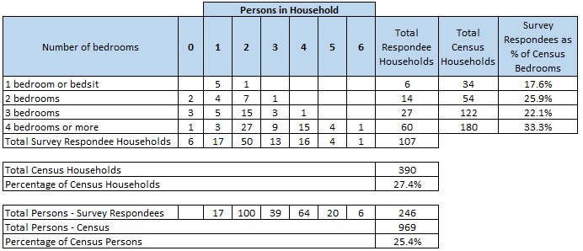

TABLE 4 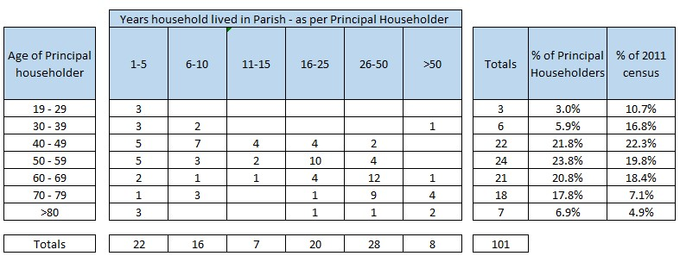
Table 4 is useful for identifying which age groups have not responded well to this survey. For example the 19 – 29 range could be specifically targeted further at discussion groups, workshops or events and venues, such as Mother and Toddler playgroups or sports clubs.

In the experience of the Rural Housing Enabler the responses to this Marsh Gibbon survey echo those normally received to similar surveys carried out in the area, i.e. the majority of responses in any survey of this kind come from:
- People who feel themselves to need housing now or in the near future.
- Their relatives.
- People involved in some way in community affairs who probably have an appreciation of the problems affecting the community as a whole, even if they do not have housing needs.
- People who wish to influence the future of the parish and help to shape new housing development to provide homes suited to the parish.

5. Part 2 - Housing Type – what type of homes do you think are required in Marsh Gibbon (please tick all that apply)
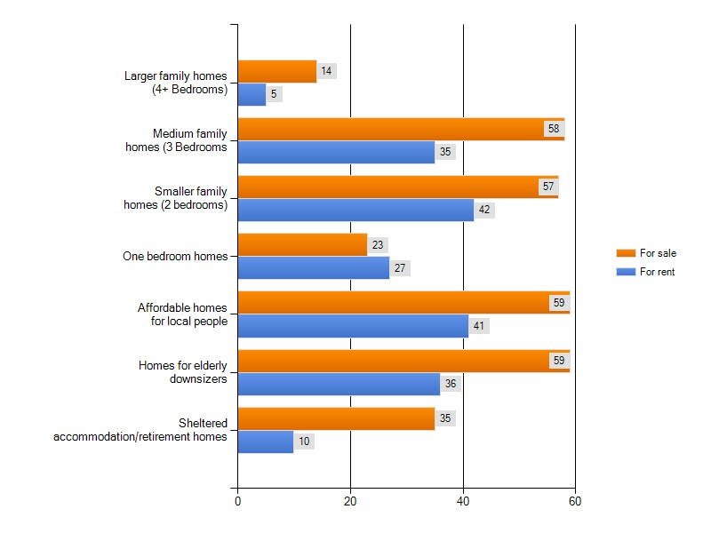
In total, 102 respondents answered this question. Of these responses, 15 indicated SelfBuild Homes (see page 17) and 3 said ‘none’ or ‘no’ further building. One additional person indicated a house and bungalow but the questionnaire allowed only one box to be checked so the second choice has been included in the ‘Other’ box.
Housing Types - For the purposes of this survey the following descriptions have been used:

Owner Occupier
Owner-occupied (i.e. financed and built by private developers for owner occupiers or private landlords, whether persons or companies). This includes accommodation that is owned outright or is being bought with a mortgage.

Private Rent
Rented privately, defined as all non-owner occupied property other than that rented from local authorities and housing associations plus that rented from private or public bodies by virtue of employment. This includes property occupied rent-free by someone other than the owner.

Affordable Housing
Affordable housing is social rented, affordable rented and intermediate housing. From April 2012 affordable housing is defined in Annex 2 of the National Planning Policy Framework 2012 (prior to this, the definitions in Planning Policy Statement 3 apply). Social rented housing is owned by local authorities and private registered providers (as defined in section 80 of the Housing and Regeneration Act 2008), for which guideline target rents are determined through the national rent regime.

- Affordable rented housing is let by local authorities or private registered providers of social housing to households who are eligible for social rented housing. Affordable Rent is subject to rent controls that require a rent of no more than 80 per cent of the local market rent (including service charges, where applicable).

- Intermediate housing is homes for sale and rent provided at a cost above social rent, but below market levels subject to the criteria in the Affordable Housing definition above. These can include shared equity (shared ownership and equity loans), other low cost homes for sale and intermediate rent, but not affordable rented housing. Homes that do not meet the above definition of affordable housing, such as “low cost market” housing, may not be considered as affordable housing for planning purposes.

6. Part 3 - Housing Need
This part of the survey helps to gain a clearer picture of future housing need in Marsh Gibbon and can form the evidence base for planning any new developments or refurbishment opportunities, as well as helping to inform future policy making over the next 20 years.
It was completed by anyone who considered they may have housing needs either now or in the future. This included parishioners who were adequately housed at present but who might at some stage want to downsize, build their own home, rent affordable homes or move up into family homes etc.

The following charts illustrate the responses collected:

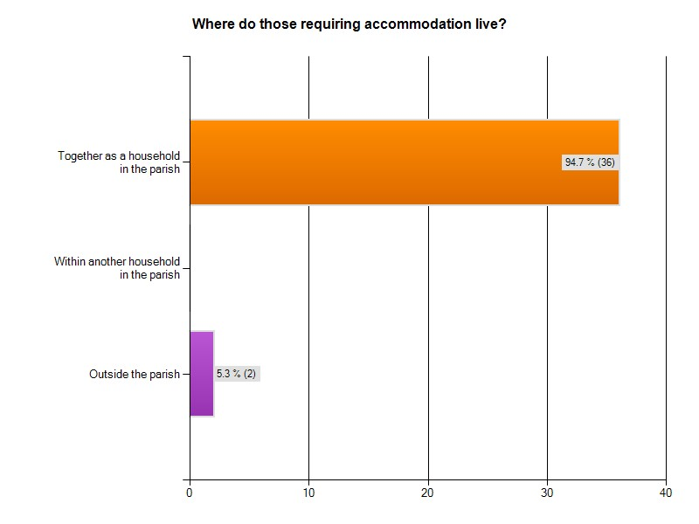
94.7% lived together as a household in the parish and 5.3% lived outside the parish but with connections to the community.

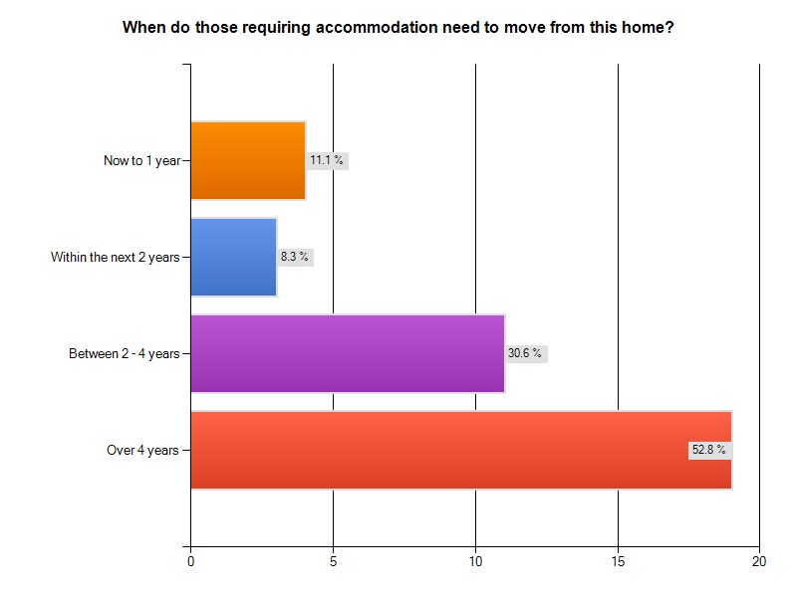

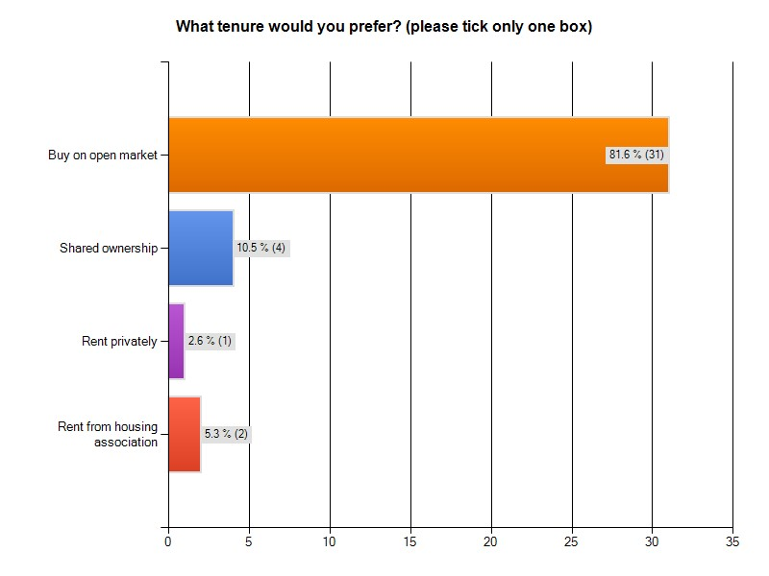

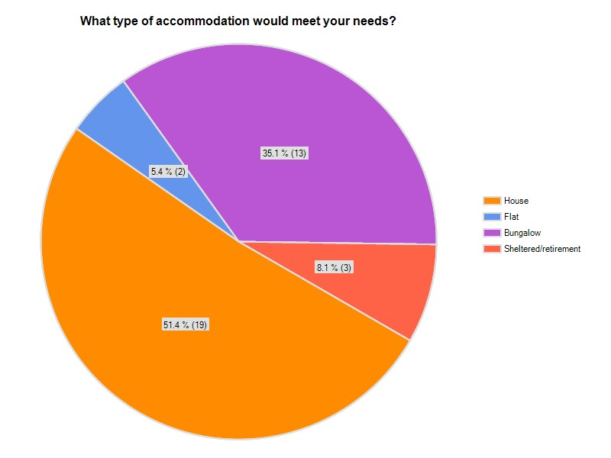

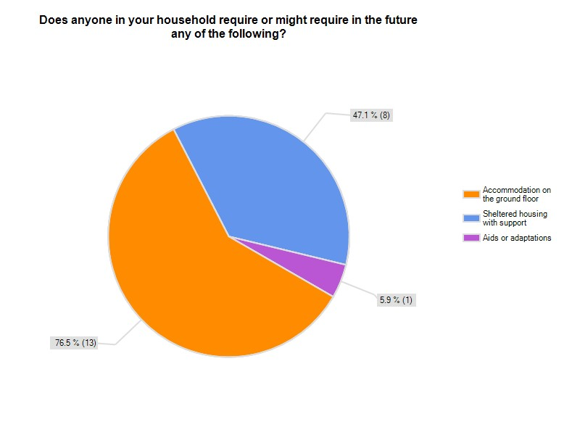

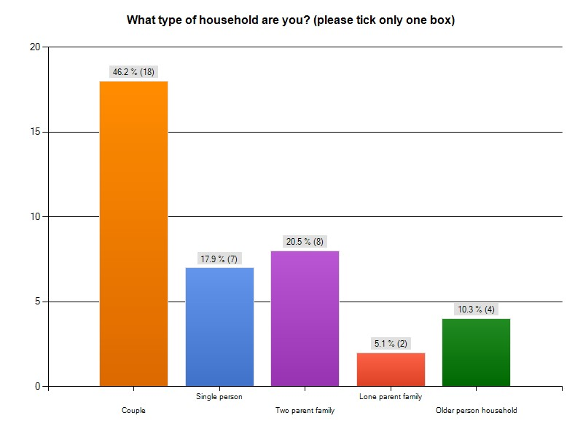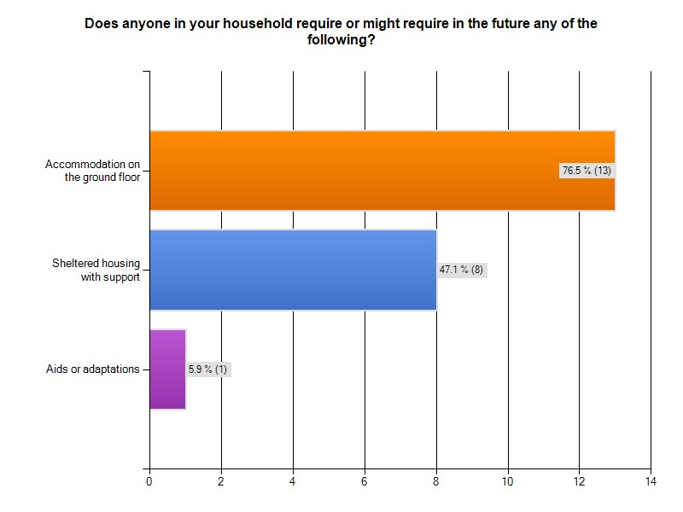

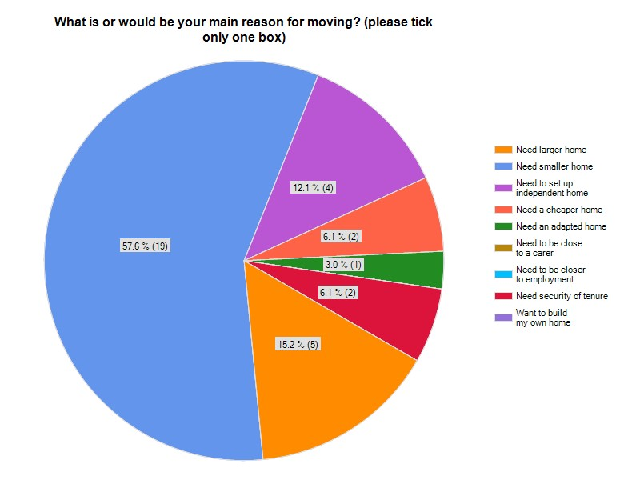

The majority of respondents to this question came from older homeowners in large (4+ bedrooms) wishing to downsize at some stage into smaller accommodation and the second largest group were growing families hoping to remain in the parish and find a larger home.
It is well documented that during the last decade there has been a marked shift in the percentage of “older” people in the community as a whole. The response to this survey in Marsh Gibbon reflects this trend. The majority of respondents to this survey were from larger 3 or 4 bedroom homes in the parish.

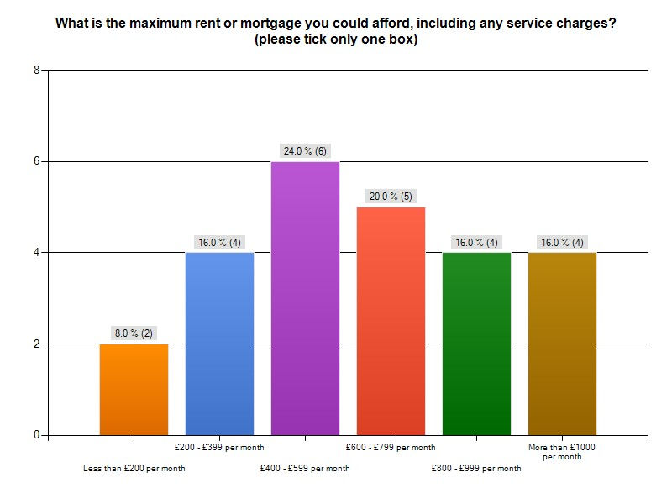
This question was not really applicable to the majority of respondents, who were owner/occupiers hoping to sell a larger property and downsize. The higher end of the chart (between £800 and over £1,000 per month), generally came from professional families, already on the housing ladder, hoping to purchase a larger property.
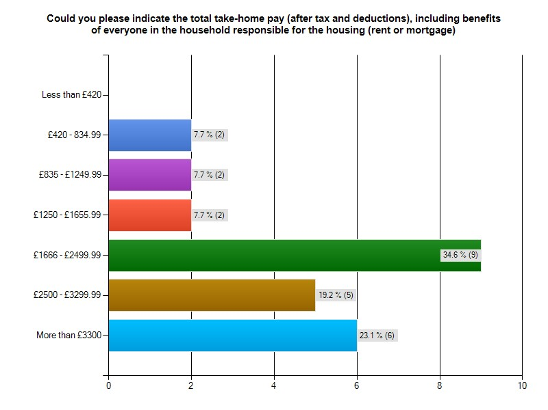

7. Comments

Space was included in the survey to allow people to make comments, and these are reproduced below in full. It is of interest to note that of the 19 comments the principal 3 themes of the comments are:
- A perceived requirement to downsize because of age
- Support for affordable housing for younger people/families
- Requirement for local infrastructure – shops/schools etc. to be upgraded
“Rather than additional housing, the village is more in need of a basic infrastructure, i.e. shops, frequent bus services, improved street lighting, footpaths and adequately maintained roads.”
    - “If we accept the principle of a gradual expansion of the village i.e. the 4 houses per year previously proposed this should be by means of small developments of mixed houses. We see no evidence of a need to build "cheap" houses which turn out not to be affordable by those who would want to live in them, it's more appropriate to have such accommodation in Aylesbury or Bicester close to employment opportunities.”
    - “The key issue is the size of any proposed development. Small developments of five houses or less that harmonise with the existing spread of properties is the way forward. Large developments of 20 or 30 houses (similar to the scheme proposed to financially support the development of the school) is not. Making Marsh Gibbon a community which people will want to live, work and contribute to should be the overriding aim.”
    - “Present home on the market for sale, not now suitable for our age. Require more modern, centrally heated bungalow type property for retirement. I may have to move nearer to town for facilities like doctors, shops, solicitors, carers and community (equity in existing property).”
    - “Marsh Gibbon is a lovely village and I hope that it remains that way after any development. Provision should be made to give accommodation to young families. However this should not be to the detriment of green open spaces. Near current properties and areas outside the village boundary should be looked at. Also, if new houses are built then provisions for villagers should be established such as a shop.”
    - “Small developments are far more preferable to large (10+ houses) plans that would destroy the community and village life. This is a traditional village that enjoys the wealth of benefits because of the slow, small changes that have happened over the years. New people moving in are able to be included and welcomed into village life because of the small numbers. Large developments would risk becoming separated enclaves.”
    - “I would like to see another type of development like Suffolk Court or a small close of bungalows on the market to buy.”
    - “If the village expands, must improve on amenities such as a village shop.”
    - “Any new houses need to be at affordable prices. The new houses built by Hastoe were very nice and of a high standard but were too expensive for local people to afford.”
    - “Extending Marsh Gibbon COFE Primary School to accommodate the last two years before Secondary School would be fantastic (and necessary) particularly if more family housing is to be created.”
    - “The additional housing that would benefit us would be retirement type homes that my mother would be able to afford to buy to enable her to live closer to us as she gets older. There is currently nothing in the village that she could afford to buy.”
    - “We love Marsh Gibbon and married in the local church. We really want to stay but a lack of housing and a clean, well-stocked friendly shop are driving us to look elsewhere. We hope this survey enables development so we can stay.”

    - “Key needs are for smaller accommodation units for young 'starter' renters or home owners and for the old who have finished families, not large family homes, of which there are plenty in Marsh Gibbon. A good residential home for locals would be valuable. All development to be in village (i.e. already built) area - - no ribbon development on roads out of village or on land outside village.”

    - “Although I have lived in the village for 30 years, should I need in the future to downsize, I would need accommodation near to either my son's or daughter's families - both many miles from Marsh Gibbon. I should however like to comment on two points. The amount of very heavy good vehicles passing through the village on its narrow lanes. The in-filling for housing development is accepted but any new estate would be detrimental to the village - and the extra traffic on narrow roads, dangerous.”
    - “More care needed to clear village of rubbish and leaves, surface water needs to be removed faster i.e. water trenches to be dug out, roads to maintained better and sooner, Car parking on roads needs looking at, traffic speeding through village needs looking at.”
    - “Off-road parking essential, far too many cars parked on footpaths, the noticeboards have posters with 2011 dates. Re-site school in Clements Lane.”
    - “Information is provided on the understanding that it is confidential and will only be used for the purpose of this survey. Any stored data is required to be stored in full compliance with the data protection act 2003 regardless of the location of stored data.”
    - “Before there are any large developments in Marsh Gibbon to cover more land so water can't drain away. The village needs a bit of TLC, gulleys need to be cleared and grass verges cut and also roadside drain that have been blocked for at least 12 months. In the summer we have lorry road sweepers that have nothing to sweep and in the winter we don't see any therefore leaves build up in the roadside drains and pavements blocking roadside drainage so water floods onto roads and freezes. Many roads have potholes and are in need of repair.

8. Additional Feedback Received

Marsh Gibbon Parish Council held a public meeting in October 2013 to solicit views about their Neighbourhood Development Plan. Approximately 60 people were in attendance. A very busy station was the mix/type of housing required, where 41 written comments were put on the flipchart. Five were not directly relevant to the question.
They report that of the 36 valid responses, 30 were in favour of either housing for the elderly to downsize into (6), starter homes for young people (9), small/mid- size homes (8) and homes for both the young and elderly (7). There were six other responses, requesting mixed developments (3), affordable/rented (2) and for local people (1)

9. Points to consider

Homes for downsizers/elderly

In September 2013, ‘Demos’ published a report called ‘Top of the Ladder’ about the chronic undersupply of appropriate housing for older people. They consider that this is the UK’s next housing crisis. “While all eyes are on those struggling to get on the bottom of the property ladder, those at the top are often trapped in homes that are too big and unmanageable. This is due to a lack of suitable homes to downsize into and in turn has a negative effect not just on older people’s health and wellbeing, but on the rest of the housing chain.”

The Top of the Ladder uses original quantitative research to investigate older people’s housing preferences and the likely impact of giving them greater choice. It estimates that if all those interested in buying retirement property were able to do so, 3.5 million older people would be able to move, freeing up 3.29 million properties. Apart from these gains, retirement housing has a very beneficial effect on older people’s health, wellbeing and social networks. It could save health and care services considerable resources.
The report suggests that this would be a triple-win for government, improving older people’s lives while stimulating the property and home-building market, at little cost to the public purse. It recommends changes to the planning code to encourage the development of retirement housing, while also providing practical help and giving financial incentives to encourage downsizing. It concludes by arguing that the Government should adopt a ‘whole chain’ view of the housing market, as helping those at the top of the ladder will unlock supply and benefit those on every other step.” *Source Demos

Affordable Housing

For the younger population the lack of finding affordable housing has been a problem for decades, but recently has reached crisis point. Incomes of those who work in rural areas, tend to be lower than the regional average which makes it difficult for people working locally. Locally for instance, for those in agriculture, tourism and village services wishing to live in the village in which they work. High house prices prevent first-time buyers from getting a foothold in the housing market. If young people are priced out of rural areas then the available pool of labour for the local economy and service sector will diminish. Alongside this, demand for services such as schools, shops and pubs will also decrease making their existence less viable.
The Royal Institute of Chartered Surveyors, Valuation Standards/Global UK, Red Book. (UK Valuation Standard) (UKVS) 3.7 conditions, state that when valuing all new build affordable homes, whether rural or otherwise the price will be based on comparable open market housing prices locally. Valuers are compelled to follow these standards and these conditions apply to rural affordable housing across the country.
The RICS standards in the Red Book bring together all factors that should be taken into consideration when valuing a new-build property, including: Value-adding factors such as: more efficient heating systems, enhanced levels of insulation and high-quality build materials which are offered as standard on Rural Exception developments of affordable housing.
Affordability for local people is achieved by selling a proportion of the equity, taking into account local financial circumstances and in line with how much the purchaser can afford. Unfortunately, because of the rise in house prices and with salaries not keeping pace, this often puts ‘affordable’ rural homes out of the reach of many. Mortgages are particularly difficult to obtain in the current climate, lenders expecting a higher deposit of at least 20% and an exemplary credit history. Rent is now charged at ‘affordable’ up to 80% of open market rental values and not normally at ‘social’ rent levels, although generally the ‘affordable’ rent is set at a level that fits within the Local Housing Allowance housing benefit.

Self-Build

Fifteen people supported self-build and four people expressed an interest in developing their own homes. The following are models of self-build available:

Self-Build one-off - The design and construction process is undertaken by the owner who also carries out a fair proportion of the actual building work too.
Contractor built one-off home- Owner manages the design process, selects a contractor who then takes care of the construction work.
Kit home - Select preferred kit home and the kit home company then erects the house.
Independent community collaboration – The community work together to acquire a site to split up into plots, then organise the design and construction of their individual homes. Possibly by way of a Community Land Trust (CLT).
Supported community self-build group - A social landlord or a community Self Build Agency helps build a group of homes together. Some funding may be available through the Homes and Communities Agency (HCA) Community Led Project Support funding to help groups get started.
Custom Build - Developer built one-off home. A developer with a site and approved design takes care of everything; to save costs.
Developer led group project - A developer organises a group and builds the homes; often, to save costs, the self-builders finish them off. Possible CLT.

10. Conclusion

From the results of this survey it is clear that the majority of the people who responded, support a mix of housing development in the parish. The most popular choices, almost equally supported were:
- Homes for elderly downsizers, for sale on the open market
- 2 and 3 bedroom homes for sale on the open market
- Affordable homes for local people.

If homes could be provided for the elderly downsizers this would free up some larger homes for the five families who expressed a need for bigger family homes. The main issues would be to ensure that the smaller homes remained in perpetuity for local people and it could not be guaranteed that there would be older parishioners in a position or with the desire to move to smaller accommodation when the units were complete. If any smaller homes built were sold outright on the open market this would not then address the problem for future generations of downsizers, as it is possible that the homes would be extended and enlarged, One solution might be to build a small scheme of 6 age-restricted homes on a fixed shared equity, leasehold basis with a Community Land Trust (CLT) holding say a 20% share. This might include a clause in the lease that prohibits extensions to ensure that the properties remained small.
Affordable homes for local people were equally-well supported with the majority of respondents indicating that they thought these homes should be for sale or shared ownership. A small scheme of around 6 affordable homes, either as a rural exception scheme, Community Right to Build Order as part of the Neighbourhood Development Plan or by way of a CLT, would be of benefit to the community but it should be noted that any properties built would always be valued for shared ownership at the open market price and a percentage of the value would then be offered to potential purchasers. In the current climate mortgages are difficult to obtain and the community might need to consider that rented tenure might be the best option.
Fifteen people supported self-build and four people expressed an interest in developing their own homes. This could also be part of a CLT or an entirely separate community group.

APPENDIX I
Contacts and signposting

HCA, HAPPI (Housing Our Ageing Population, Panel for Innovation) Report June 2009. http://www.homesandcommunities.co.uk/Housing-Ageing-Population-Panel-Innovation

The Joseph Rowntree Foundation, www.jrf.org.uk

Age Concern Fact Sheet, Housing Options SF50. www.ageconcern.org.uk. This factsheet includes information on:
- Help available for people to stay in their home
- Homeshare scheme
- Rented housing from the council or housing association
- Private rented
- Sheltered housing
- Moving in with relatives

Rural Services Network www.rsnonline.org.uk. The Rural Services Network is a membership organisation devoted to safeguarding and improving services in rural communities across England. The network has three main purposes:
- Representing the case for a better deal for rural service provision
- Exchanging useful and relevant information
- Developing and sharing best practice

ACRE
Action with Communities in Rural England is the national umbrella body of the Rural Community Action Network (RCAN), which operates at national, regional and local level in support of rural communities across the country. They aim to promote a healthy, vibrant and sustainable rural community sector that is well connected to policy and decision-makers who play a part in delivering this aim. ACRE is nationally recognised for its expertise in ensuring rural community-led solutions are central to public policy debate.
www.acre.org.uk

http://www.defra.gov.uk/crc/rural-housing-at-a-time-of-economic-change

http://www.selfbuildportal.org.uk/

http://www.communitylandtrusts.org.uk/

As defined in the Aylesbury Vale Housing & Economic Growth Assessment (GL Hearn, 2011)

