A G E N D A

Meeting of Bowes Parish Council at Bowes School on
Wednesday 9th December 2015 at 7.30pm

1. Apologies –
2. Minutes of the Meeting held Tuesday 11th November 2015
3. Matters arising (unless dealt with later in agenda)
4. Finance & Accounts – See summary below
Receipts since last meeting £33.00 Allotment Holders
Expenses since last meeting £13.40 K Adams £373.60 H Overfield £93.40 HMRC

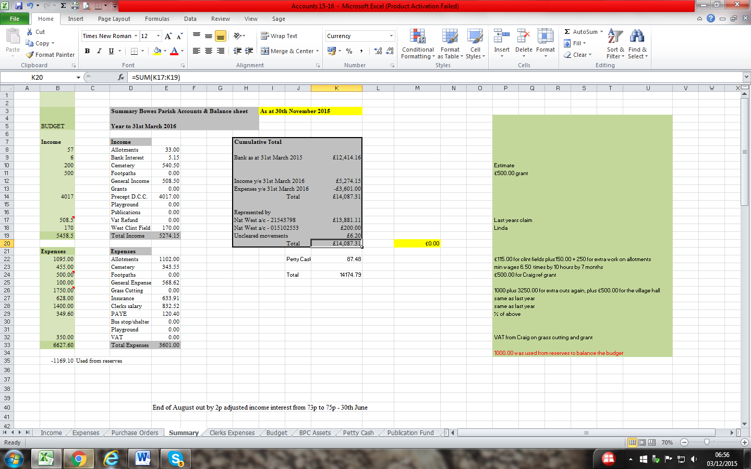
Precept form to complete

5. Planning

6. Correspondence
Changes to Post Office opening times
Bin Collection dates for notice board

7. Cemetery & Village maintenance

8 Allotments

9 Play Park

10 Parish Paths

11 AOB

