To all Great Milton Parish Councillors:

You are summonsed to attend a PARISH COUNCIL MEETING on Monday 17th September 2012 at 7.30pm in the Pavilion:

AGENDA
88/12 Apologies for Absence

89/12 Register of Disclosable Pecuniary Interests for this Meeting
To receive declarations of interest in matters on the Agenda.

90/12 Minutes of the Previous Meeting
To approve and sign the minutes of the PC meeting held on Monday 16th July 2012 and the Planning Meeting held on Tuesday 4th September 2012.

91/12 Matters to Report
To receive an update on matters progressed since the last meeting not appearing as Agenda items and reports from District and County Cllrs if present.

92/12 Correspondence and Public Discussion
To receive items of correspondence and take questions from the public.

93/12 Planning Applications
A There are no Planning Applications to consider at this meeting.

B To review any planning decisions received and any outstanding planning matters.

94/12 Employment of the Clerk
To formally resolve to employ Kelly Wing in the role of Parish Clerk to start on 24th September 2012 and to review and approve the contract of employment.

95/12 Document and Archive Management
To consider a proposal by the Clerk to destroy paper records of Planning Applications and Accounts more than 10 years old and to approve the use of a shredding service.

96/12 Maintenance of Trees Backing 13 Fullers Field
To consider a request from the residents to cut back the trees on the Recreation Ground backing their property.

97/12 Web Site Review
To consider alternative web site provision, review appropriate options available on the market and agree any actions.

98/12 Financial Resolutions
A To authorise cheques for payment:

Joanna Botha. Salary August (£367.20) and September (£254.22). £621.42
Joanna Botha. Expenses. TBC
Jonathan Dudley. Bulletin production - September issue. TBC
Mhp Internet. Annual updating costs – Plan P. £504.00
OALC. Training course for new clerk. £66.00
Countrywide. Rec cutting July 13, 24 and August 10, 18. £360.00
Countrywide. Verge cutting – April, May, June, July. £760.00

B To review the donation requests for the last six months, including requests from Old Field Committee for a contribution towards the £96 cost of installing a new gate and a one-off grant in the region of £175 to cover the next insurance premium due in May 2013.

C To review the Issues Arising report from the external auditor, approve and accept the Annual Return and to agree an action list for finance.

99/12 Any Other Business
This part of the meeting may be used to bring the Clerk’s attention to village maintenance issues, inform the meeting of any notices or diary dates and to propose future agenda items.

All members of the press and public are very welcome at this meeting.

The next meeting of the Great Milton Parish Council will be held on Monday October 15th 2012 starting at 7.30pm in The Pavilion.

Signed:
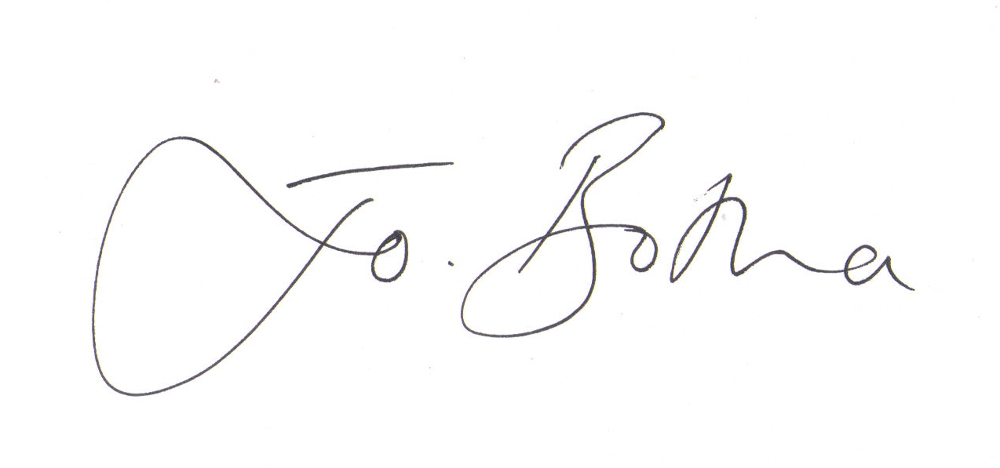

Joanna Botha
Clerk/Responsible Finance Officer to Great Milton Parish Council

