Trust Headquarters Fred Bloggs
Millennium Point Thriftwicket Lane
Waterfront Business Park Haytons Bent
Waterfront Way Ludlow
Brierley Hill Shropshire
West Midlands SY8 2BE
DY5 1LX What3Words:
(you can find your 3 words on https://what3words.com)

DATE

Dear Sir
Re: Ambulances Accessing My Address
I would like to request that in future emergency vehicles attempting to access my address do NOT use Titterhill which is the route directed by SATNAV. This lane is very narrow, steep and winding and emergency vehicles have got stuck using this lane in the past.
Could they please use the route from Lower Hayton to Haytons Bent. At Hayton’s Bent take the right turn to Thriftwicket Lane and the Bull Ring. Please see the route in green in the map below:

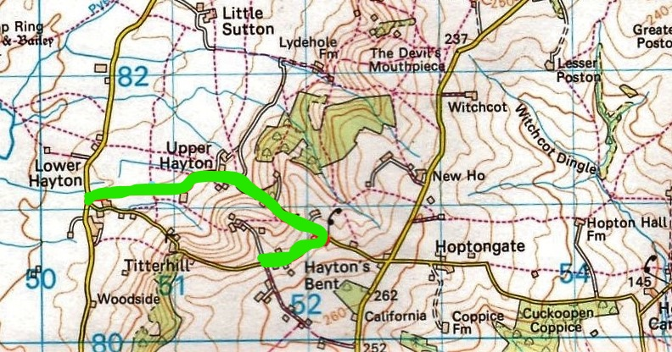
Yours faithfully

Mr J Bloggs

