To all Great Milton Parish Councillors:

You are summonsed to attend a PARISH COUNCIL MEETING on Monday 18th July 2011 at 7.30pm in the Pavilion:

76/11 Apologies for Absence
To receive apologies for absence from the meeting.

77/11 Register of Interests for this Meeting
To receive declarations of interest in matters on the Agenda.

78/11 Minutes of the Previous Meeting
To approve and sign minutes of the meeting held Monday 20th June 2011.

79/11 Matters to Report
To receive reports from the local PCSO, District and County Cllrs if present and any updates on actions since the last meeting (not appearing as Agenda items).

80/11 Correspondence and Public Discussion
To take questions from the public and receive items of correspondence.

81/11 Planning Applications
There are no planning applications to consider this month.
A To review any Planning Decisions received.
B To receive any updates on outstanding planning matters.
C To review the Addendum of Changes to the South Oxfordshire Submission Core Strategy

82/11 Improvements to the Green by Ardfield
To discuss and agree the action needed to prepare a proposal for this work.

83/11 Overgrown Tree on Common Land
To receive an update on the outcome of discussions with Southern Electric and to agree any further action necessary by the Parish Council.

84/11 Responses to the Parish Plan Questionnaire
To review the results of the Parish Plan questionnaire and discuss and agree the next steps required.

85/11 Change to the Great Milton Parish Council Standing Orders
To agree a permanent change to the usual schedule of GMPC meetings from the second Monday of the month to the third Monday and to amend the Standing Orders accordingly.

86/11 Financial Resolutions
A To authorise the following cheques for payment:
Joanna Botha. Salary. £322.18
Joanna Botha. June Bulletin. £69.98 (8 hours x £8.747)
Jonathan Dudley. July Bulletin. TBC
Countrywide Grounds Maintenance. Recreation Ground Cuts. 11th, 21st and 28th April (£270.00). 9th and 30th June (£180.00). £450.00
Open Spaces Society. Membership. £40.00

B To review a quarterly bank reconciliation and analysis of actual receipts/payments versus budget.
C To receive the internal auditor’s final report for the year-ending March 31st 2011.
D To review and approve the paperwork prepared for the Annual Return for the year-ending March 31st 2011.

87/11 Any Other Business
This part of the meeting may be used to bring the Clerk’s attention to village maintenance issues, inform the meeting of any notices or diary dates and to propose future agenda items.

All members of the press and public are very welcome at this meeting. The date of the next Great Milton Parish Council meeting will be Monday September 19th 2011 at 7.30pm in the Pavilion.

Signed:
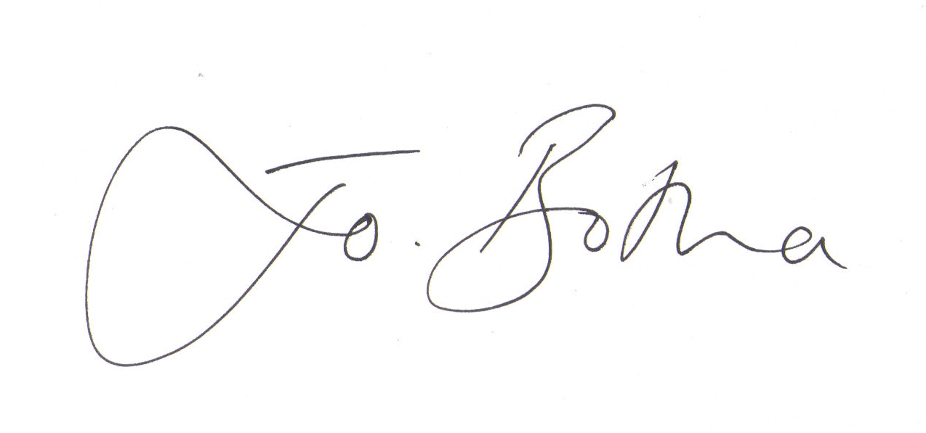
Joanna Botha, Clerk/Responsible Financial Officer

