SUTTON VALENCE PARISH COUNCIL

From the Clerk:
Mrs Janet Burnett E-mail: clerk@suttonvalence.org.uk The Parish Office Sutton Valence Village Hall Sutton Valence
Tel: 01622 844135 Maidstone
Web site: www.suttonvalencepc.kentparishes.gov.uk Kent ME17 3HS

To all members of the Parish Council
You are hereby summoned to an extra ordinary remote meeting of the Parish Council to be held on Thursday April 29th 2021 at 7.00pm when the following business is proposed to be transacted:
The Chairman to ask if anyone is recording
- Apologies for absence
- Declaration of lobbying
- Declaration of Changes to the Register of Interests
- Declaration of Interest in items on the Agenda
- Requests for Dispensation
- Planning
- Recommendation to be made on the following applications:
- 21/501084/FULL New Bungalow Gladwish Farm Headcorn Road ME17 3EL
Change of use of agricultural land to residential. Erection of an outbuilding.
- 21/501781/FULL Amberley, Chart Road, ME17 3AW
First floor front and side extension.
- 21/501780/FULL Amberley, Chart Road, ME17 3AW
Single storey rear extension.
- 21/501640/FULL Rosmann, Leeds Road, ME17 3LT
Erection of a dwelling with new vehicle access.
- 21/501734/FULL Winterwood Farm, Chartway Street, ME17 3DN
Erection of an accommodation block for agricultural workers comprising 30 bedrooms with unisex shared shower rooms, male and female WC's, internet room, TV room, laundry, kitchen, and social room, with associated ancillary outside amenity area and landscaping.

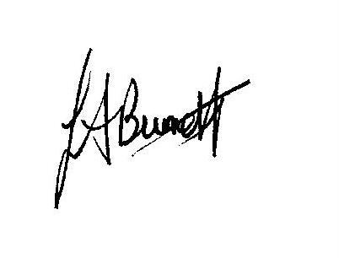
Janet Burnett – Clerk to the Council 22/4/21

THIS MEETING IS TAKING PLACE REMOTELY ON ZOOM. IF YOU WISH TO ATTEND THE MEETING PLEASE
JOIN USING THE DETAILS BELOW

https://us02web.zoom.us/j/85185134942

