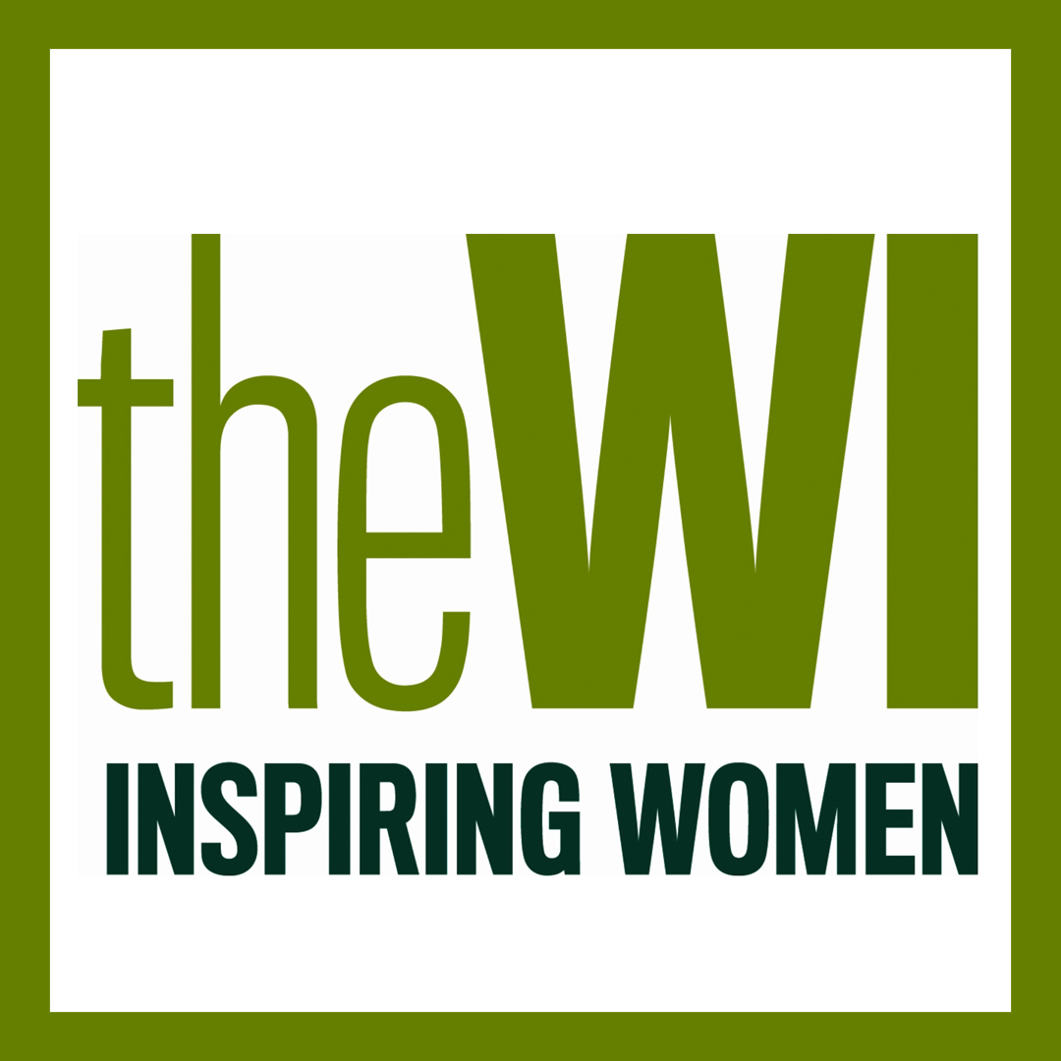

Halam WI Programme 2021

Tuesday 8th June 2021 WI Birthday Party at The Milk Shed

Tuesday 6th July 2021 Halam Village Treasure Hunt

Tuesday 3rd August 2021 “There’s more to tea than a bag in a mug” – TBC

Tuesday 7th September 2021 Essential Oils for Health and Wellbeing

Tuesday 5th October 2021 Breast Health and Bras

Tuesdaty 2nd November 2021 Christmas Crafts

Tuesday 7th December 2021 WI Christmas Party at The Waggon

January 2022 No meeting

Tuesday 1st February 2022 AGM, Resolutions and Quiz

Tuesday 1st March 2022 Interactive Indian Cookery Demonstration

All meetings 7.30 – 9.30pm in Halam Village Hall, unless stated otherwise

Email halamvillagewi@gmail.com for any further information

