SUTTON VALENCE PARISH COUNCIL

From the Clerk:
Mrs Janet Burnett E-mail: clerk@suttonvalence.org.uk The Parish Office Sutton Valence Village Hall Sutton Valence
Tel: 01622 844135 Maidstone
Web site: www.suttonvalencepc.org.uk Kent ME17 3HS

Notice is hereby given of a remote meeting of the Parish Council to be held on Thursday March 11th 2021 at 7.00pm when the following business is proposed to be transacted:
The Chairman to ask if anyone is recording
Submissions from Public, Police, Community Support Warden, County or Borough Councillors
- Apologies for absence
- Declaration of lobbying
- Declaration of Changes to the Register of Interests
- Declaration of Interest in items on the Agenda
- Requests for Dispensation
- Minutes of the meetings held 28th January and 11th February 2021 to be agreed
- Covid 19
- Annual Parish Assembly
- Rural Market Town Group
- Electrical charging points
- Consultations
- KALC
- Social media
- Training
- Data Protection
- Planning
- Recommendation to be made on the following applications:
- 21/500512/FULL Little New Barn Farm New Barn Road Hawkenbury TN12 0ED
Siting of 10no. holiday pods, erection of a small pole barn to house 1no. portable shower block, 1no. portable toilet block, construction of temporary car park and waste storage compound.
- 21/500941/TPOA Mount House Lower Road ME17 3BN
TPO application to reduce crown of one Sycamore by up to 3m leaving final height of 15m and 10m radial spread and sever ivy.
- 21/501025/FULL The Surgery South Lane Sutton Valence ME17 3BD
Erection of single storey prefabricated modular building to form office.
- Enforcement – to take place in closed session.
- Finance
    - Authorisation of payments
    - Bank Balances
    - Income
    - Expenditure
    - Bank Reconciliation
- Performance against budget
- Recreation and Open Spaces
- War Memorial Play Area and field
- Weekly and monthly inspections
- Annual Play area inspection – awaiting repairs
- Replacement fence – awaiting repairs

- Car Park
- Pavilion update
- Football
- Extension of football season
- Tennis Court resurfacing update
- Harbour Play Area and field
- Weekly inspection
- Monthly inspection
- Open Spaces
- Peter Shayler’s Fair
- Extension of Conservation Area
- Parish Council field in South Lane
- Tree survey
- PROW
- Roads & Transport Group (inc. Lighting)
- Roads
- Public Transport
- Lighting
- Allotment
Cllr Ward to report
Risk assessment to be agreed
- Police
- Correspondence
- Village Hall
- CCTV
- Agenda items for next meeting
- Date of next meeting

Janet Burnett – Clerk to the Council 5/3/21

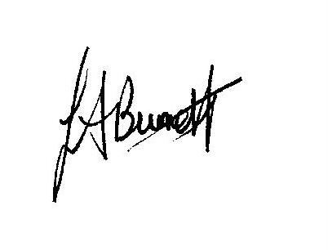

THIS MEETING IS TAKING PLACE REMOTELY ON ZOOM. IF YOU WISH TO ATTEND THE MEETING PLEASE
JOIN USING THE DETAILS BELOW
https://us02web.zoom.us/j/86906235183

List of payments at time of agenda

Legal & General 118.84 Clerks pension
J Burnett 1743.59 Salary
J Burnett 2.69 Postage vat return
J Burnett 5.50 Elastic ropes
J Burnett 26.39 Plumbing items - allotment
Haven Power 221.86 Street lighting January 2021
Tailored Auto Pension 13.20 Pension admin
Corona Energy 18.76 Pavilion
XLN 57.53 Telephone
Lloyds Credit charge 121.08 Microsoft 11.28, charges 3.00 KALC training 102.00, Ionos 4.80 domain name
G Ward 180.00 Payment to I Betts – sheep manure
Village Hall 342.91 Room Rent
HMRC 611.34 Paye month 10
Prime One Maintenance 173.46 Street lighting
Hugofox 35.99 Website
IOG Membership

