STANTON LACY PARISH COUNCIL
Signed: 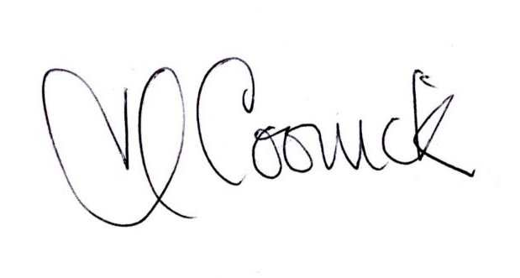 (Parish Clerk) Date: 12/9/2020
You are invited to attend a meeting of Stanton Lacy Parish Council at 7.30pm on Thursday 17th September 2020 via Zoom
(Meeting ID: 832 0787 2566 Passcode: 548642 or details on Parish website)

Members of the public are welcome to join the meeting.

AGENDA
- Apologies for absence (please notify Clerk prior to meeting)
- Declarations of any disclosable pecuniary interest or non-pecuniary interest from members regarding items on the agenda.
- Public involvement session. Members of the public are able to ask a question or make a statement. If it is not possible to respond at the meeting, a written response will be provided at a later date.
- Approve the minutes of the Ordinary meeting held on the 16th July,2020.
- Matters Arising:
  - Election of Vice-Chair
  - To receive a report on closure of Bromfield Post Office
  - To decide upon response to BT’s proposed removal of Telephone Box, Vernolds Common
  - To agree membership of Sub-committee on Housing Needs and Development Options
  - To decide upon action regarding Potholes
  - To decide upon action regarding concealed entrance
  - To decide upon representative to Village Hall Committee
  - Respond to Consultation on Planning White Paper ‘Planning for the Future’
  - Respond to the Consultation on ‘Shropshire Draft Housing Strategy (2020-2025)
  - Respond to Consultation on the Draft Local Plan
  - To decide upon Environmental Maintenance Contract

- Finance:
  - To approve the finance report and bank reconciliation
  - To approve forecast of expenditure
  - To decide upon clerk having a bank card

- Reports From Representatives:
  - Shropshire Council

- Agenda Items for the next meeting
- The next meeting to be held on 19th November,2020 at 7.30pm.

Copies of the agenda and minutes are available from the Clerk, Heather Coonick:
www.stantonlacyparish.org email: stantonlacypc@gmail.com Tel: 07817607355

