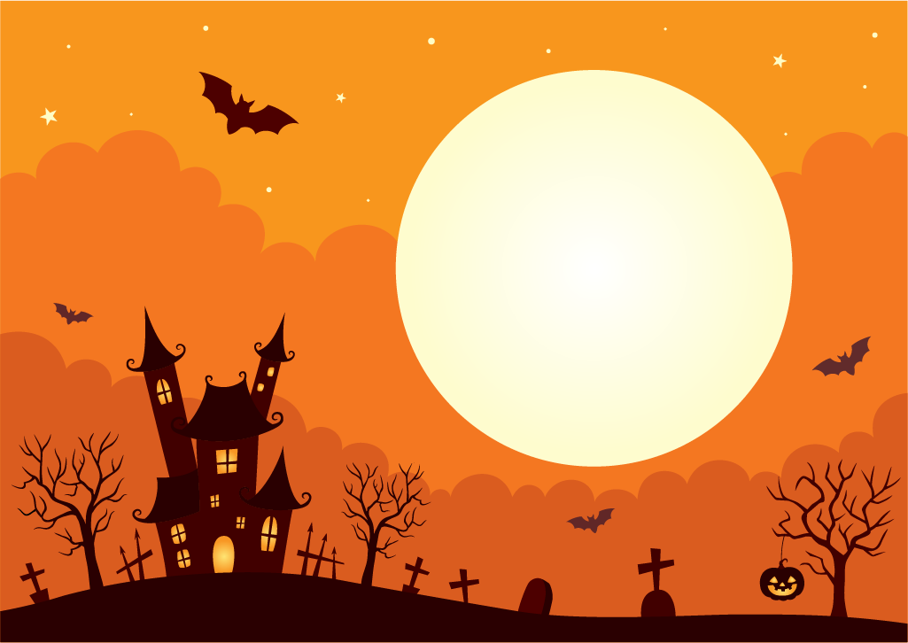

HALLOWEEN PARTY

SATURDAY 26TH OCTOBER FROM 7PM

FANCY DRESS ENCOURAGED (PRIZE FOR BEST COSTUME)

PUMPKIN PINATA

APPLE BOBBING

HEADS OR TAILS

HIGHER/LOWER

FOOD INCLUDED

£5 PER TICKET

PLEASE LET DEB HOOPER KNOW IF YOU WOULD LIKE A TICKET